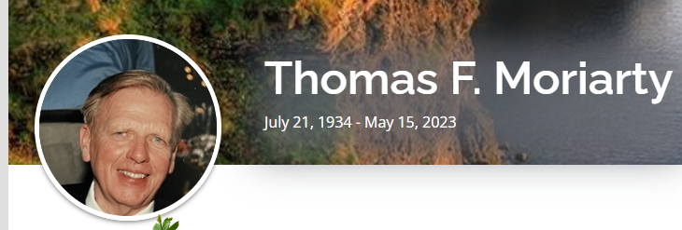

Chicopee- Thomas F. Moriarty, a long-time resident of Chicopee, passed away on May 15, 2023 at the age of 88. Born and raised in Holyoke, Tom was the son of the late Thomas P. and Mary (Moynihan) Moriarty. He was a graduate of Holyoke High School (1952), College of the Holy Cross (1956), and received his Master’s degree and Doctorate in History from the University of Notre Dame and worked as a history professor, teaching for many years at Elms College, and also at Fordham University, NY, and Talladega College in Alabama. Always proud of his Irish heritage, Tom also taught Irish Language courses at Elms and was a founding member of the Irish Cultural Center in W. Springfield. He was a member of the American Conference for Irish Studies, the John Boyle O’Reilly Club, the Holyoke Parade Committee (former Ambassador Award winner), the Ancient Order of Hybernians, and was a past Parade Marshal for Chicopee. Tom was a member of the Chicopee Historical Society and had been an active parishioner at Holy Name Parish, in Chicopee, serving as a Lector and Eucharistic Minister. Tom is survived by his wife Bonnie (McLean) Moriarty, as well as their children, Thomas F. Moriarty, Jr, of Glastonbury, CT and Catherine “Kate” R. Moriarty and her partner, Angelo DeGuglielmo, of Springfield. He also leaves behind his cousins, Noreen Moriarty and William Moriarty, both of Holyoke, his brother-in-law Daniel McLean and his wife, Deborah, of Naugatuck, CT, as well as nieces, nephews, and extended family members. Calling hours for Tom will be held on Thursday, May 18, 2023, from 4:00 to 7:00pm at Corridan Funeral Home, 333 Springfield St., Chicopee. Funeral services will be Friday, May 19, beginning at 10:00am at the funeral home, followed by a Liturgy of Christian Burial at 11:00am at Holy Name Parish, 94 Springfield St., Chicopee. In lieu of flowers, memorial contributions in Tom’s name can be made to Our Lady of the Elms College, 291 Springfield St. Chicopee, MA 01013, or to the Alzheimer’s Association (www.alz.org/get-involved-now/donate). To leave your condolences or to share a memory with the family, please visit www.CorridanFuneral.com

