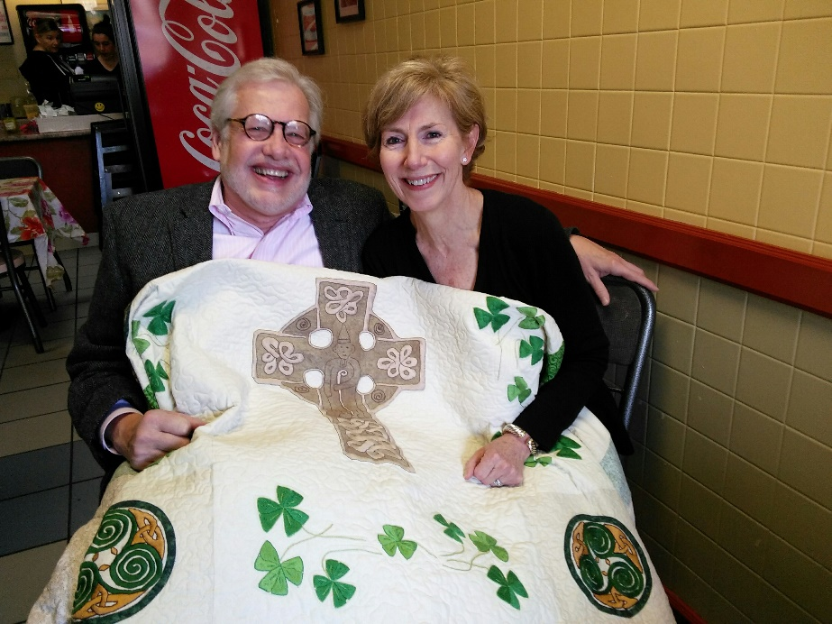
Dear Friend of the LAOH,
We are happy to announce that the winner of the 2017 LAOH Quilt Raffle is JoAnn Davis of West Springfield, shown here with her husband David Longworth at Mrs. Mitchell’s Kitchen, where the winning ticket was drawn, and also where she purchased her raffle ticket.
We want to thank you for your support of the Ladies Ancient Order of Hibernians Annual Raffle.
The money we have raised each yearfor the past seventeen years has gone to the Maurice Donahue Scholarship Fund, and to local charities such as the Women’s Shelter, Bethlehem House, and Kate’s Kitchen.
We wouldn’t be successful in this yearly endeavor without your support, for which we are truly grateful.
Paula Paoli, Chair of the LAOH Annual Quilt Raffle, and President of the Holyoke, MA LAOH

Noranne Duquette and Barbara Twohig, Co-Chairs

