The Ancient Order of Hibernians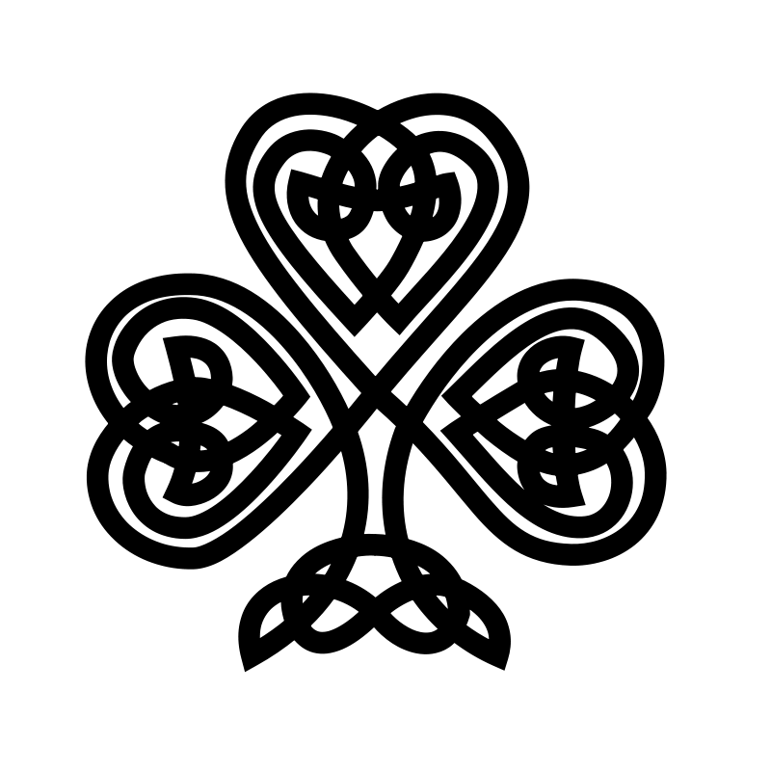
James A. Curran-Division One
& The Ladies Ancient Order of Hibernians
Invite the Public To The Annual

IRISH NIGHT IN HOLYOKE!
The DANIEL P. CURRAN Irish Night

FEATURING
BOSTON’S NOEL HENRY IRISH SHOW BAND

SATURDAY FEBRUARY 24, 2018
DOORS OPEN AT 6:00PM-DINNER AT 7:15PM
THE WHEREHOUSE?
109 LYMAN STREET, HOLYOKE
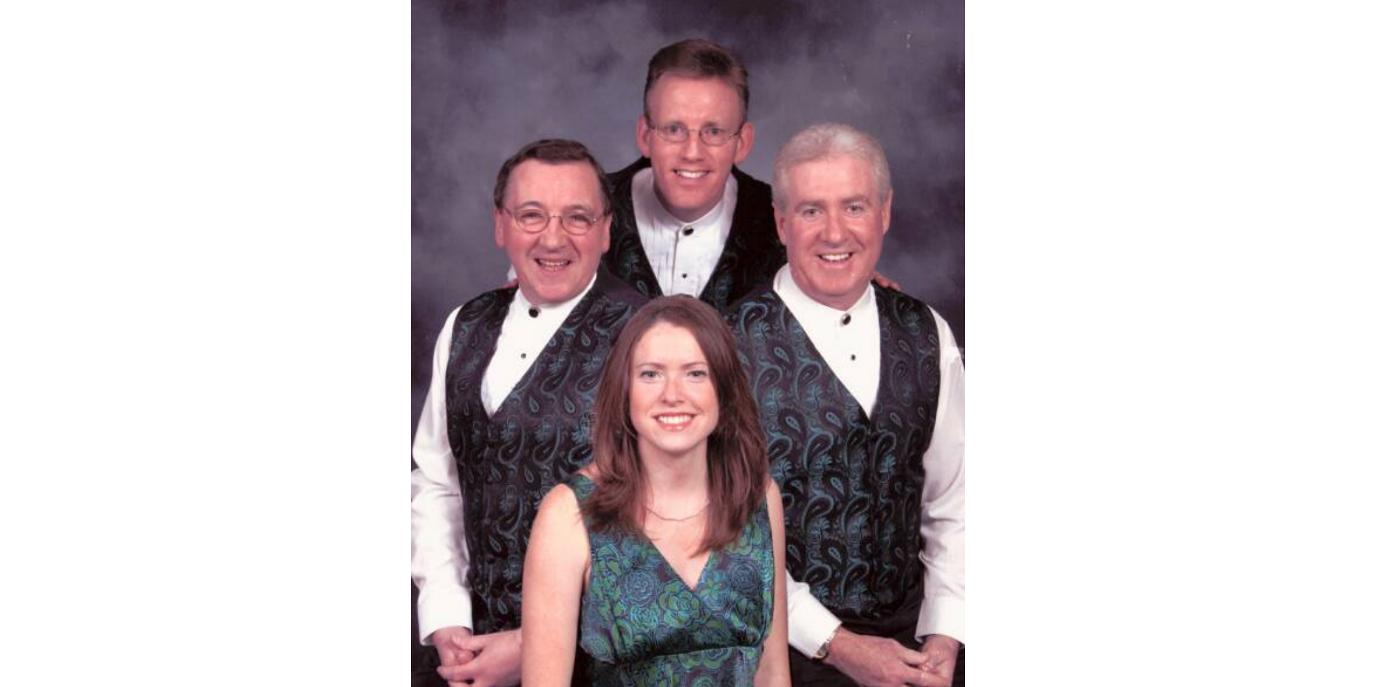

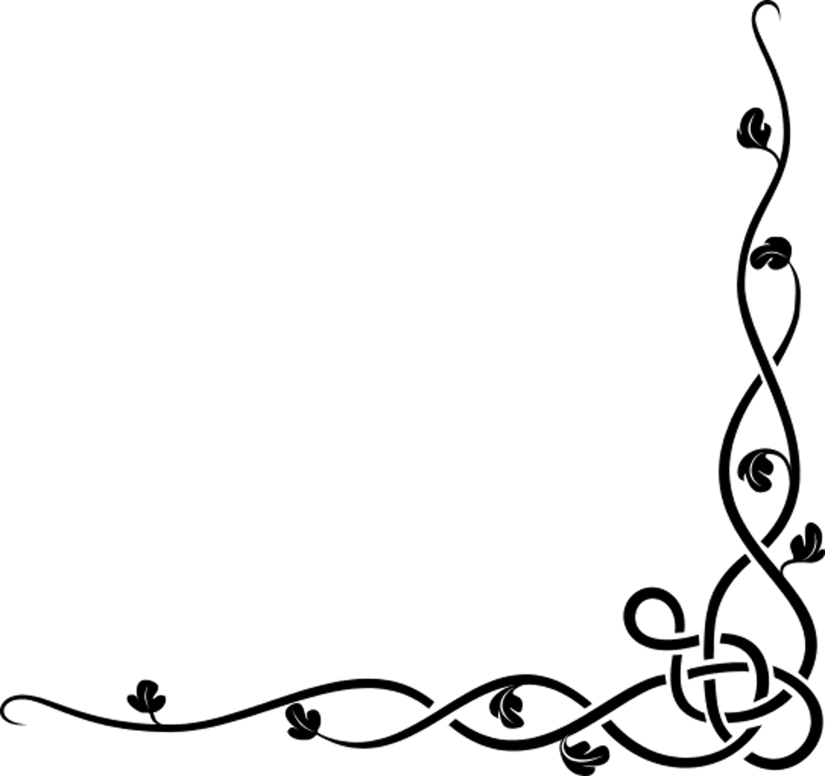

- SERVING A TRADITIONAL CORNED BEEF AND CABBAGE DINNER
- SERVNG DANNY CURRAN’S FAMOUS CORNED RIBS
- ADDITIONAL ENTERTAINMENT BY THE CASSIN SCHOOL OF IRISH DANCE
- PIPER MATT O’CONNOR OF THE SPRINGFIELD KILTIE BAND

$30.00 PER PERSON
ADVANCED RESERVATIONS REQUIRED
TICKETS AND TABLE RESERVATIONS AVAILABLE UNTIL FEBRUARY 20, 2018
CALL JOE O’CONNOR @ 413-627-7148
Or Fran Hennessey @ 413-785-5687

TICKETS ARE AVAILABLE ON- LINE AT:
Eventbrite.com Search: “ Irish Night In Holyoke”
TO BENEFIT THE MAURICE A. DONAHUE MEMORIAL SCHOLARSHIP-DONATIONS WELCOMED!
‘TIS THE EVENT OF THE SEASON’
WWW.AOH-HOLYOKE.COM

