WE HAVE A WINNER!
The 2019 LAOH QUILT was won by LISA LEACH of Worcester, MA
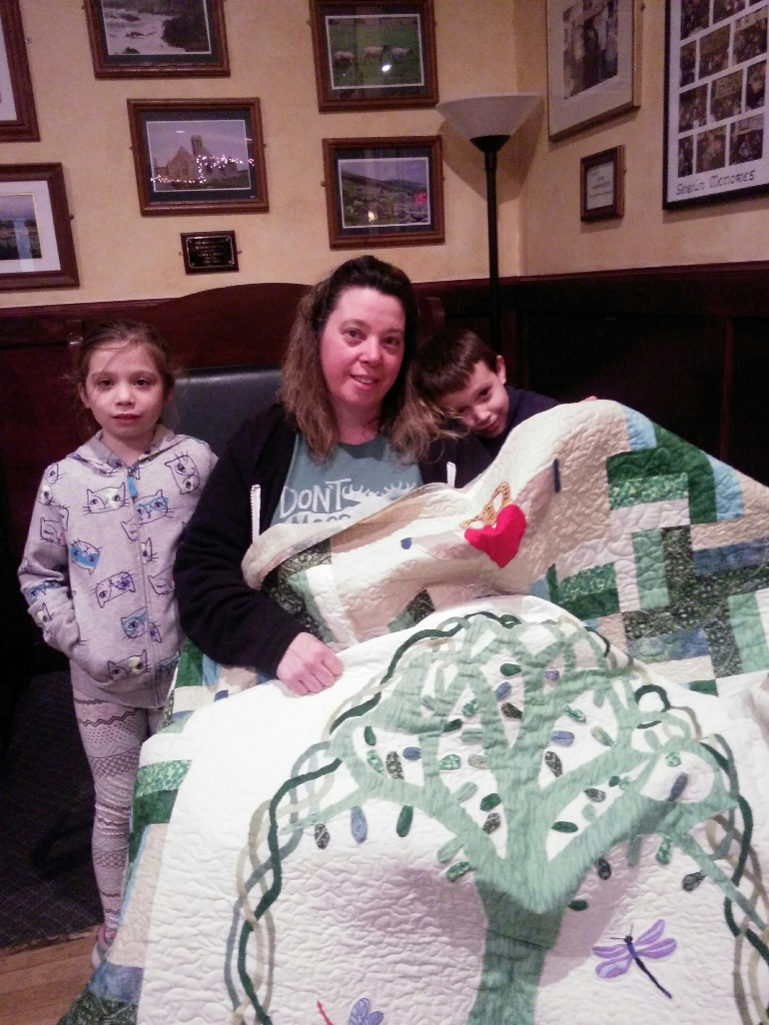
Thank you for your support of the
Ladies Ancient Order of Hibernians

