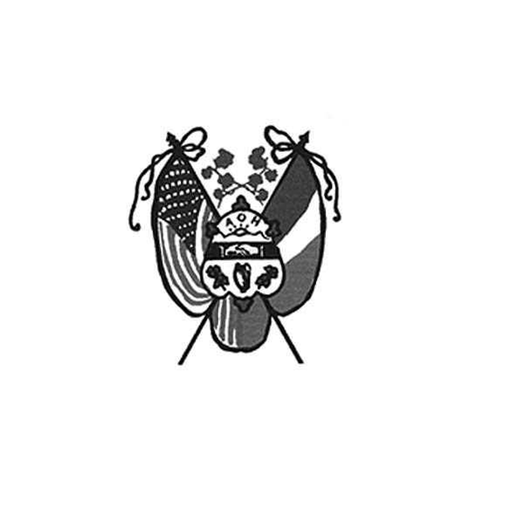 **Ancient Order of Hibernians**

**of Hampden Hampshire Counties**

PO Box 6535

Holyoke, MA 01041-0826

[www.AOH-Holyoke.com](http://www.aoh-holyoke.com/)

Next meeting – AOH – Monday, September 9, 7 p.m. at The Wherehouse?

LAOH – Monday, September 9, 6 p.m. at The Wherehouse?

 Next meeting Monday, **October 7, 2024**

 ​  **In ainm an Athar agus an Mhic agus an Spiorad Naoimh, Amen.**

**Dear Brothers,**

**It was a very busy summer and September will be just as active.**The summer started off with Charlie O’Connell’s scenic train ride though Westfield to the Ashley Reservoir and later ended with good food, great music and even better friendship at the Hennessey Hoe-Down (I mean summer picnic). I would like to thank everyone who volunteered and participated at these events. Like I previously said, we aren’t slowing down with 3 events this month. September 17 is both Holyoke Day at The Big E and the Half-Way to Saint Patrick’s Day wine tasting at the Glendale Ridge Winery. Both events are free with the exception of food and drink. It would be great to have excellent participation at both events. More details to follow. The third event is the LAOH Annual Par 3 Golf Tournament at The Holyoke Country Club on Saturday, September 21. The ladies need golfers, sponsors and raffle prizes. Let’s make this another great success. Finally, I want to thank everyone for all our hard work and will give an update of the national convention at the September meeting. **Joseph O’Connor, AOH Division President**

**It is with a great deal of sadness to learn of the passing of Barbara Bernard. Our dear friend. Barbara was the 2014 recipient of the Hibernian Christian Charity Award for improving the lives of the people of Hampden/Hampshire Counties**and was a longtime supporter of Hibernian events. She will remain in our hearts forever. Our thoughts and prayers go out to her family. May she rest in Peace.

**Don't forget the September meeting is on the 9th, because of Labor Day.** **Nominations for the offices of the AOH will take place at our September and October meetings.** Voting will take place in November. If you are interested in serving, submit your name at either meeting.

**Welcome to the newest AOH members, Russ McNiff Sr. and Ryan Kokoski.**

**Over 200 people attended the annual picnic two weeks ago at the Summit View pavilion.** It was a beautiful day for great music by Jim O’Connor and the Boston Blackthorne Band with excellent food and hospitality from Hamel’s Catering. Thanks so much for all the people who donated gifts, worked the event and to all who attended. It was a Great Day for the Irish!

**Half Way to St. Patrick’s Celebration-will take place 5-7 p.m. at Glendale Winery in Southampton on September 17.** The event features Dee Reilly. Admission is free with food and wine available for purchase.

*To Be Irish Is A Blessing, To Be a Hibernian an Honor*

**For those who want to celebrate at The Big E and ride on the trolley in the parade on Holyoke Day, Tuesday, September 17,** please be at Gate One by 5:30 pm. David Bartley will have entry tickets to the fair (Gate One is toward the Agawam bridge end of Memorial Ave.). The parade kicks off at 6 p.m.

**Our fiscal year for membership starts in November.**An email will be sent out mid- September as a reminder. We have a total of 93 members. 78 are up to date with 15 in arrears. Please contact financial secretary, Peter Hogan, if you are unsure about your dues at 413-330-6635 or [pjhogan71@gmail.com](mailto:pjhogan71@gmail.com)

**In partnership with the Polish National Credit Union,**the AOH and LAOH are conducting a Food and Clothing Drive for Providence Ministries from September through December. Drop off items at the PNCU, 270 Westfield Road, Holyoke.

**Newly-arrived AOH Polo shirts are available for sale, $70.**They come in all sizes. To purchase your shirt, contact President Joe O’Connor at 413-627-7148.

**Thank you to John Cadigan for agreeing to chair the By-Laws Committee.**John will be in charge of updating the club’s by-laws.

**LAOH Notes**

**Thanks to Rose Pratt and the Ladies from the LAOH who made sandwiches for Kate’s Kitchen during the summer.**The schedule for sandwich making this fall are October 27, November 24, and December 15.

**Welcome to the LAOH’s newest member, Ann Kelly!**

As mentioned, the LAOH is getting ready for the **Annual Par 3 Golf Tournament**, on September 21st at the Holyoke Country Club. Thank you to Nora McMahon for chairing this important event. If you would like to sponsor a hole, please contact Nora McMahon at 413-218-2092 or [driscona@gmail.com](mailto:driscona@gmail.com) or Paula Paoli at 413-210-6031- or [paulaakpaoli@gmail.com](mailto:paulaakpaoli@gmail.com).

**At the Golf Tournament, the LAOH will be sponsoring a collection for the Holyoke Veterans Home (formerly the Holyoke Soldiers Home). There is a wish list on the Holyoke Hibernian website.** We thank you for considering to make a contribution for our veterans, who have given so much for us. We will be collecting the needed items at the golf tournament. Please contact Paula Paoli at the above phone number or email above with any questions about the collection for our veterans.

**The LAOH is preparing for elections, so if you would like to serve the division in an office, now is the time to step up and run for an office on the board.**More information will be coming on the elections at the September meeting, including the duties of the division officers.

**Contact Paula Paoli at 413-210-6031, or**[**paulaakpaoli@gmail.com**](mailto:paulaakpaoli@gmail.com)**; or Pat Murphy at 413-532-3121, if you are unsure your 2024 dues are paid.**

**If you are receiving a printed copy of the newsletter and want it sent by email instead,**please contact Paula Paoli at **413-210-6031, or**[**paulaakpaoli@gmail.com**](mailto:paulaakpaoli@gmail.com) to make the change.  We appreciate those who have changed to email to save our division the cost of printing and postage.

*To Be Irish Is A Blessing, To Be a Hibernian an Honor*

**Upcoming Events:**

**Half-Way to St. Patrick’s Celebration-**5-7 p.m. at the Glendale Winery in Southampton on September 17.  The event features Dee Reilly. Admission is free with food, wine, available for purchase.  A donation of a non-perishable food item to be delivered to the Providence Ministries for the needy is welcomed.

**Holyoke Day at the Big E -**Tuesday, September 17. AOH & LAOH members are asked to meet at Gate One (near the Agawam bridge) at 5:30 p.m. The parade kicks off at 6 p.m.

**LAOH Par 3 Golf Tournament**– Saturday, September 21 at the Holyoke Country Club. If you would like to sponsor a hole, donate a raffle prize, or sign up to play, please contact Nora McMahon at 413-218-2092 or [driscona@gmail.com](mailto:driscona@gmail.com)

**Kate’s Kitchen –**Please join us- contact Rosalie Pratt at 413.532.1677 if you would like to volunteer. Tentative schedule dates for sandwich making are October 27, November 24, and December 15.

**Food and Clothing Drive for Providence Ministries**- September through December. Drop off items at the PNCU, 270 Westfield Road, Holyoke.

**Nomination for Club Offices**- submissions at the September and October meetings with elections in November

**ICC News**

**Éilís Kennedy –** National Award-Winning Irish singer/songwriter from Dingle, Eilis Kennedy performs at the ICC Monday, September 16. Doors open at 4:30 p.m. with the performance from 6-8 p.m. Tickets are $30 for ICC Patrons and $35 for the general public. To purchase tickets call 413-342-4358

**The Trinity Pub**

The Trinity Pub is open Wednesday–Saturday with the pub open from 4 – 10 p.m. and dinner served from 5 – 9 p.m. For reservations and gift certificates call 413-342-4358.

**Irish Cultural Center Book Club**

**Join the Irish Cultural Center Book Club.** Enjoy good craic and delve into Irish and Irish-American literature, with guided discussion in a welcoming, relaxed atmosphere. This event is open to all, Patrons and the general public.  The meeting will take place on Thursday, September 12 from 5:30–6:30 pm at the ICC. This month’s selection is **Northern Spy by Flynn Berry**. The story revolves around a producer at the BBC and mother to a new baby, Tessa is at work in Belfast one day when the news of another raid comes on the air. The IRA may have gone underground in the two decades since the Good Friday Agreement. As the news reporter requests the public’s help in locating those responsible for the robbery, security footage reveals Tessa’s sister, Marian, pulling a black ski mask over her face. The Book Club is free to join. Please register ahead so we know how many people to expect. Register online at: <https://www.irishcenterwne.org/september-book-club/>.

**Entertainment at the Trinity Pub –**Wednesdays, September 11, 18 & 25, Trad Seisun; Fridays, September 13- Alibi: September 20 – County Line: September 27, Piper-Hopkins Band; Saturdays, September 17 – Ireland Parish: September 14 – New Leaf: September 21- The Blaney Brothers: September 28 – The Healys.

**Remember the AOH in Your Will**

**Please consider the Order when writing or rewriting your will,**and add a paragraph with the lines of   “I leave to the Ancient Order of Hibernians in America (X percent of my estate or a specific dollar amount) for its charitable works.” 

**The Healy’s Irish Radio program is on the air every Saturday from 9 a.m – 11 a.m. on WARE Radio, 97.7 FM and 1250 AM. It is also streamed online at**[**classichits977.com**](http://classichits977.com/)**and available anytime at**[**healysirishprogram.com**](http://healysirishprogram.com/)**.**

**In continued memory of Doc Dean and our commitment to Kate’s Kitchen.** Providence Ministries is in need of canned goods. Please bring a can or two to the meeting on Monday night.

 Gerry Healy’s name was picked for the 50/50 raffle. Gerry was not in attendance at the meeting. You have to be present to win.

(Editor’s Choice) Check out the Irish Comedy trio, Foil, Arms & Hogg on Instagram or YouTube. They are funny.

 If any reader has other interesting social media sites on Irish history, culture, sport, or politics send me the link and I’ll share in the next issue. Owen Donohue at [Helloh@aol.com](mailto:Helloh@aol.com)

**In ainm an Athar agus an Mhic agus an Spiorad Naoimh, Amen.**