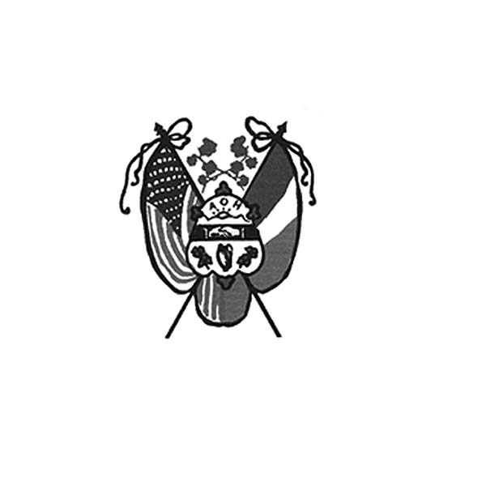 **Ancient Order of Hibernians**

**of Hampden Hampshire Counties**

PO Box 6535

Holyoke, MA 01041-6535

[www.AOH-Holyoke.com](http://www.aoh-holyoke.com/)

Next meeting – **AOH** – Monday, April 7, **7 p.m.**

at The Wherehouse?

**LAOH** – Monday, April 7, **6 p.m**. at The Wherehouse?

​**In ainm an Athar agus an Mhic agus an Spiorad Naoimh, Amen**

Dear Brothers,

**March started with a beautiful flag raising ceremony at City Hall where the tri-color was proudly displayed.** Much thanks to all who participated. Special kudos to Fran Hennessy, Peter Tallman, Peter Hogan, Matt O’Connor, Sean Cahillane, Father Francis Reilly, LAOH State President, Barbara Twohig, Mary Kate O'Connor, Kit Collamore, Cheryl Dupont and John Cadigan.

The month just kept on getting better when the Holyoke City Council honored the Ancient Order of Hibernians award recipients. Thank you to Holyoke City Councilor David K. Bartley.

At the Communion Breakfast, Jay Driscoll was truly a master of ceremony at the Wyckoff Country Club. Guest Speaker Teri Schindler gave an excellent talk while our own Christen Charity Award recipient, Owen Donohue’s remarks were poignant and inspiring.

A big thank you to all who helped the Parade Committee hand out bibs to registered runners and blocked intersections for crowd control.

What a day for a Parade! The Float Committee was up bright and early Sunday morning preparing the floats for the trip up to the Holyoke Community Charter School to be judged. This year our float received a blue ribbon and won First Place in the Religious Themed category. Hundreds of thousands of Parade goers cheered the AOH’s two floats, assorted dignitaries and our large Irish Flag. Peter Hogan’s Float committee consisted of JD Watson, Kenny Watson, Dave Magadan, Paula Paoli, Dan Murphy, Pat Hogan, Wade Allen,

Kay O'Connor, and Pam Brough. Fran Hennessy again transported marchers to the charter school. The parade started on time.

(Except, someone forgot Owen’s sign) but that did not stop Owen, Saint Bridget, Saint Patrick and all our marchers who entertained the crowd.

I would personally like to thank everyone for the hard work over the last 3 months. We showed what it is to be a Hibernian and proudly promoted our Irish culture and heritage.

A special thank you to Mark Dupont from The Dioceses of Springfield for highlighting the AOH producing a great segment for the tv program, Real to Reel.

At the April meeting a discussion will be held about the up-coming AOH convention . Any member going will be put on a committee.

Sincerely,

President Joseph O’Connor

**Challenged by a typical cold Parade wind,** champion Irish dancers on the AOH Dancing Float, Mike Jensen & Maeve Loring were outstanding. Cassidy MacDonald & Mya Brown joined the champions with soft shoe dances. Special thanks to dance-dad Jerry Brown who walked along the float to help them when they needed something.

*To Be Irish Is A Blessing, To Be a Hibernian an Honor*

**In gratitude for their many years of selfless service, the staff at Kate’s Kitchen has nominated Paul Hogan and Charlie Popp to receive an award posthumously at their April 25 gala at The Log Cabin.** Sister Margaret McCleary, a past Hibernian Christian Charity Award winner and founder of Kate’s Kitchen will also be honored.

**At the April meeting, there will be two important items discussed.** The first being the Hennessey Hoe Down. The club will need to decide both the venue and the date. The second concerns the St. Brigid (travelling) float where new signs would be constructed. The signs will replace the Patrick Pierce quote with one recognizing the AOH’s support of our veterans. This float will again travel to the Watertown Memorial Day Parade and have been invited to the Westfield 4th of July Parade where we will transport Vietnam War veterans. Our float will then be entered into the Patriotic category for the Saint Patrick’s Parade. Peter Hogan will present a cost estimate for the work.

**We still have 15 members not in good standing for 2025. Notices again will be sent.** Anyone with questions about their dues can contact financial secretary Peter Hogan at pjhogan71@gmail.com or 413-330-6635. Due to a few complaints, starting in 2025 please send your dues to AOH, c/o Peter Hogan (AOH Financial Secretary) 22 County Road, Holyoke, MA, 01040-9606. Only paid members for 2025 are eligible for our 50/50 raffle & need to be present at the meeting.

,

**AOH Polo shirts are available for sale for $70.** They come in all sizes, make great Saint Patrick Day gifts and are a stylish addition to anyone’s wardrobe. To purchase your shirt, contact President O’Connor at 413-627-7148.

**LAOH Notes**

Dear Sisters:

**I hope this newsletter finds everyone healthy and getting ready for spring with new hopes and beginnings.**

Well, the month of March was busy, starting off with the Irish Flag raising at city hall. Our Irish Soda Bread sales took on a life of its own all over Holyoke.

To all the ladies who volunteered- your efforts paid off. Other volunteers were busy distributing and collecting Irish Flags (over 250 of them) at four cemeteries in Holyoke.

It was very nice for the LAOH & AOH and the award winners to be recognized by the Holyoke City Council on March 18th prior to their meeting.

So proud of the Ladies who rolled up their sleeves and helped pass out the Road race runner bibs on Friday and Saturday of parade weekend.

At the March meeting Carolyn Leahy was sworn in as our newest member.

Don’t be surprised if you see some new LAOH swag around town, the black soft-shell jackets are a hit, as always. For anybody wishing to still order a jacket, please contact me at [laohmarykateoconnor@gmail.com](mailto:laohmarykateoconnor@gmail.com) and I will put you in contact with Christopher Ferriter. I will be bringing previously- ordered jackets to the next meeting.

In April the ladies will be swearing in another new member for the 3rd consecutive month. Our newest candidate for membership is Mary Chase Bartley.

On April 26, 6:30pm -9pm The Ladies Ancient Order of Hibernians will be a proud sponsor for the Kentucky Derby Kickoff Party, “Cocktails for a Cause-Each Moment We Are Alive”, for more details go to www.eachmomentwerealive.org.

On Wednesday April 30, 2025 at 4:30 pm. The LAOH Div 2 will be celebrating our Charter 128 years strong, this celebration will coincide with the Membership Drive to take place at the Irish Cultural Center of Western Massachusetts in West Springfield. All are welcome to attend and share your thoughts on our organization. More details at next meeting.

*To Be Irish Is A Blessing, To Be a Hibernian an Honor*

Please keep in mind that time is running out if you want to attend the 2025 LAOH-AOH State convention on Cape Cod May 30-June1, 2025. Please see the email from Patty Clayton dated, 3-28-2025 with all details and information.

Don’t forget that the peanut butter and jelly gals will be getting together on Sat April 12, at 10:00 at Rosie Pratt’s house to prepare 100 sandwich meals for Kate’s Kitchen, these meals will be delivered to Kate’s Kitchen on Sunday 13th. All are welcome to attend. For more details, call Rosie at 413-532-1677 or 413-517-5346.

Please contact Kit Collamore if you have any questions about your $25.00 annual LAOH dues at (413)364-7484.or email Kit at kitc62@yahoo.com. The 2025 dues are now due, you may also send your dues to LAOH, P.O. Box 0052, Holyoke MA 01041-0052.

If you are receiving a printed copy of the newsletter and want it to be sent by email instead, please contact Patty Clayton at setpoint@comcast.net . We appreciate those who have changed to email to save our division the cost of printing and postage.

Looking forward to seeing everyone at the April 7th meeting @ 6pm at The Wherehouse.

Thank you ladies for all you do for our organization

Mary Kate O’Connor

President Div 2 Holyoke MA

**Upcoming Events:**

**Kate’s Kitchen –** next dates to prepare peanut butter and jelly sandwiches are April 13, May 18 and June 22. Please call Rosalie Pratt at 413-517-5346 if you have any questions.

**April 25 gala at The Log Cabin to honor Sr. Margaret, Paul Hogan, and Charlie Popp**

**April 26, 6:30pm -9pm** **Kentucky Derby Kickoff Party**, “Cocktails for a Cause-Each Moment We Are Alive

**April 30, 2025** -**at 4:30 pm** **Membership Drive** at the Irish Cultural Center

**AOH/LAOH State Convention**-at Cape Cod - May 30 through June 1

**Hennessey Hoe Down (summer picnic) –** to be discussed at the April meeting

**Irish Cultural Center News**

**The Trinity Pub**

The **Trinity Pub** is open Wednesday–Saturday with the pub open from 4 – 10 p.m. with dinner served from 5 – 9 p.m. The bar is now open on Sundays from noon to 6 p.m. (drinks only). For reservations and gift certificates call 413-342-4358.

**Music at The Trinity Pub –** Wednesdays, April 9, 16, 23, 30 and Thursday, April 3 - Trad Seisun; Fridays, April 4 – Piper Hopkins; April 11 – BeBop; April 18 – Baird Souls; Saturdays, April 5 – Dee Reilly; April 12 – Irish Thunder; April 19 – Jimmy McArdle and Jerry Murphy; April 26 – The Healys.

**Irish Cultural Center Book Club**

**In March, the ICC Book Club will be reading “The Alternatives” by Caoilinn Hughes** on Thursday, April 10, 5:30 – 6:30 at the ICC. The Book Club is free to join. [Please register ahead](https://www.eventbrite.com/e/january-book-club-at-the-irish-cultural-center-tickets-1117916902549) so we know how many people to expect. [Register online >](https://www.eventbrite.com/e/january-book-club-at-the-irish-cultural-center-tickets-1117916902549) at [www.irishcenterwne.org](http://www.irishcenterwne.org).

**Join the ICC for a special evening with award-winning Irish author Caoilinn Hughes on Tuesday, April 22.** The ICC’s Book Club also chose her latest novel, The Alternatives, as April’s book club selection. This event is free and open to everyone – whether you’re a book club member or simply a fan of great literature! We kindly ask that you register in advance.

Doors open at 4:30 pm, with the presentation, including readings and a lively Q&A, running from 5:30–6:30 pm. The Trinity Pub bar will be open, and after the talk, we invite you to stay and enjoy complimentary pizza and salad. Feel free to bring a dessert to share if you’d like. We look forward to welcoming you for an engaging and enjoyable evening!

**Remember the AOH in Your Will**

**Please consider the Order when writing or rewriting your will,** and add a paragraph with the lines of “I leave to the Ancient Order of Hibernians in America (X percent of my estate or a specific dollar amount) for its charitable works.”

**The Healy’s Irish Radio program is on the air every Saturday from 9 a.m – 11 a.m. on WARE Radio, 97.7 FM and 1250 AM. It is also streamed online at classichits977.com and available anytime at healysirishprogram.com.**

**In continued memory of Doc Dean and our commitment to Kate’s Kitchen.**  Providence Ministries is in need of canned goods. Please bring a can or two to the meeting on Monday night.

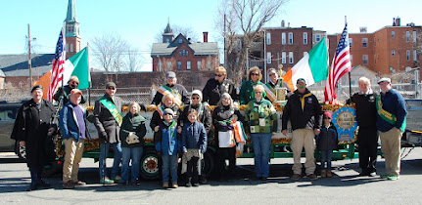

**In ainm an Athar agus an Mhic agus an Spiorad Naoimh, Amen**