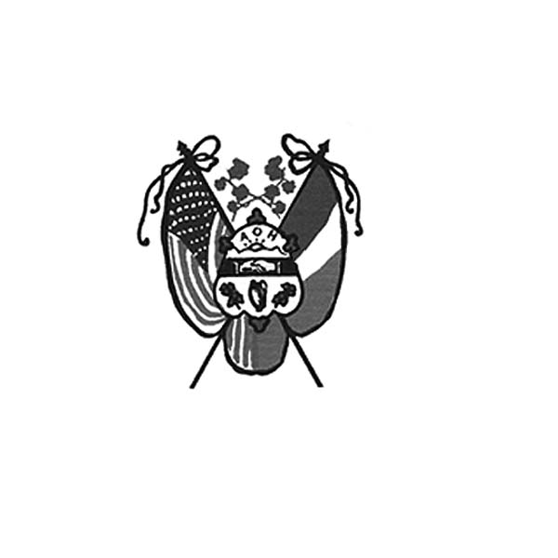
Ancient Order of Hibernians
of Hampden Hampshire Counties
PO Box 6535
Holyoke, MA 01041-6535
www.AOH-Holyoke.com

Next meeting – AOH & LAOH– Thursday, December 4,
at The Christmas Party at the Summit View Banquet House

Nollaig Shona agus Athbhliain faoi Mhaise Daoibh
Merry Christmas and Happy New Year

Dear Brothers,
Merry Christmas and a Happy New Year!
“It was a truly remarkable feeling last week not only to present a $500.00 monetary donation, but also be part of the team that collected food and clothing for Kate’s Kitchen and the Providence Ministries for the Needy in conjunction with the Polish National Credit Union and Blessed Sacrament School. Together, we make a real difference in our community. Thank you.”
Joseph O’Connor
President AOH Div. 1 Holyoke

March 2026 raffle calendars make great Christmas stocking stuffers and will be available at our Christmas dinner party. Get them before they are sold out. Only $10.00 each, there is a daily prize of $50.00 and $500.00 on Saint Patrick’s Day, March 17. Contact Peter Hogan at 413-330-6635, if you would like them delivered. Remember that if your name is drawn, it goes back in, so you have multiple chances to win.

The Adult Christmas party will be Thursday, December 4, 6-9 pm at The Summit View in Holyoke.
For reservations, call Joe O’Connor at 413-627-7148 by December 1. Tickets for LAOH and AOH members are $10.00 and $20.00 for members’ guests. The Christian Charity award winner, the AOH Man of the Year and the LAOH Woman of the Year winners will be announced at the party.

On Saturday, December 13, the AOH will join many other organizations across Western Mass to help with the Wreaths Across America decorating at the Agawam Veterans Cemetery. Shuttle busses will be bringing participants from the Six Flags parking lots to the cemetery. A brief ceremony will begin at 10 a.m., followed by the placement of wreaths. The event is widely attended, so you should get there early. If you have any questions, please call President Joe O’Connor at 413-627-7148.

The Children’s Christmas Party will take place the next day, Sunday, December 14, from 10:00 am to 1:00 pm at The Wherehouse? 109 Lyman St. Holyoke. Volunteers are needed to help set up, clean up, and assist with activities during the party. Please call Kit Collamore at 413-364-7484 to sign up your child, grandchild, niece or nephew, or a friend that you would like to sponsor for the party. Price is $20:00 per child.

Attention AOH members!!! Our fiscal year for dues starts on November 1st of each year. Please get your $30.00 dues in for 2026. Contact Financial Secretary Peter Hogan if you're not sure if you are up to date on dues. He can be reached by email at pjhogan71@gmail.com or by phone at 413-330-6635. Dues are $30.00 per year. Make checks payable to AOH & mail to Peter Hogan, 22 County Road, Holyoke MA 01040-9606.

“To be Irish is a Blessing, to be a Hibernian is an Honor.”
Thank you to Dan Murphy and Aiden Moriarty on the successful membership drive held at the Irish Cultural Center in October. At the November meeting, we welcomed into the Hibernians, Jim Lawrence, Ed Shea, John Fogarty and Marc Rogers. The club has now reached 97 members. We are aiming for 100 by the beginning of the New Year.

The AOH and LAOH will be preparing PB&J sandwiches for Kate’s Kitchen on Sunday, December 14. Contact Rose Pratt at 413-532-1677 if you want to help. Margaret’s Pantry Needs: meals in a can, like Chef Boyardee, instant potatoes, peanut butter, stuffing, elbow macaroni, ziti, and soups. Please bring items to the Christmas Party.

LAOH News

Dear Sisters,

Since our last meeting in November, I would like to extend my sincere thanks to the ladies who assisted at the Mater Dolorosa School spaghetti supper November 5, Rosie Pratt, Peggy Reynolds and Cheryl Dupont. Also, I would like to thank the women who accompanied me to Margaret’s Pantry to present our check to Brenda Lamagdelaine in support of our community, Pat Pluta, Kit Collamore, Patty Clayton, Cheryl Dupont, Rosie Pratt and Peggy Reynolds.
Thank you as well to the ladies who helped at the St. Jerome’s Craft Fair on November 9 and to all who attended to show support. Paula Paoli and Abigail Griffin were vendors for Celtic Designs at the Craft Fair.
I would also like to congratulate several of our members who serve on the board at the Children’s Museum, Pam Brough, Sue Cannon, Eileen Leahy, Kim Gaughan, Sarah Gehring, Carolyn and Paige Leahy for hosting a beautiful evening on November 15. What you do for the community, and especially for the children, is truly remarkable.
As a reminder, there will be no division meeting in December on the first Monday. Instead, I look forward to seeing everyone who can attend at our Adult Christmas Party on December 4 at the Summit View, where we will also announce our 2026 Woman of the Year. It’s not too late to call Joe O’Connor for tickets at 413-627-7149, but it is getting close.
I also want to remind everyone that on December 14 we will hold our annual Children’s Christmas Party.
I am very grateful to our member, Kit Collamore for coordinating this wonderful event. For details, please reach out to Kit directly at 413-364-7484. It is not too late to sign up your child, grandchild, niece, nephew, or a friend that you would like to sponsor.
Thank you to Kathy Sliwa, Eileen Leahy, Patty Clayton, Mary Haley, Marie Zurheide, Kim Gaughan, Pat Pluta, Kathy Dunn, Peggy Reynolds, Celeste R, Cheryl Dupont and Rosie Pratt who gathered in November at Rosie’s house for the peanut butter and jelly assembly. Your kindness knows no boundaries.
On November 11, the Ladies Ancient Order of Hibernians delivered personal clothing, toiletries, and over 150 cards to our own Holyoke Veterans Home. Thank you to Kathy Krisak, Jackie Reardon, and Peggy Reynolds for coordinating this heartfelt and important effort.

We have several meaningful events coming up in December:
• LAOH MA State Board Meeting: December 7 in Lynn, MA.
Anyone wishing to attend, please reach out to me.
• Monastery Heights Visit: December 10 on Monastery Avenue, West Springfield at 6 pm. We will donate 85 throw blankets and sing for the residents. Thank you to Marie Zurheide for coordinating this beautiful event. All are welcome to meet there.
• Next PB&J Assembly: Friday, December 12 at 6 PM at Rosie’s house.
• Wreaths Across America: December 13 in Agawam, beginning at 8:30 AM.
• Children Christmas Party Sunday Dec 14 at the Wherehouse? Holyoke.

In ainm an Athar agus an Mhic agus an Spiorad Naomh, Amen

For the first time in 2025, the Ladies Ancient Order of Hibernians has adopted a family. We will be supporting five children, ages 2 to 12, through our partnership with Judy Falcetti, a retired Holyoke Public School teacher along with a group of City Elves.
I hope everyone has a wonderful December and look forward to seeing everyone at our next meeting in the New Year on January 5, 2026

In friendship, unity, and Christian charity,
Mary K O’Connor
LAOH Division 2 Holyoke President

Upcoming Events

Kate’s Kitchen - Sunday, December 14. Contact Rose Pratt if you want to help at 413-532-1677.
Adult Christmas Party - Christmas party: the Hibernian adult Christmas party will be Thursday, December 4, 6-9 at The Summit View in Holyoke. For reservations by December 1, call Joe O’Connor at 413-627-7148. Tickets for ladies and gentlemen members are $10.00 and $20.00 for member’s guests. The Christian Charity, Ms. Hibernian and Mr. Hibernian will be announced at the party.
Wreaths Across America – Saturday December 13. Agawam Veterans Memorial Cemetery, 10 am. Meet at the Six Flags parking lot where busses will transport everyone to the cemetery. The event is widely attended so get there early. For more information, contact President O’Connor at 413-627-7148.
Children’s Christmas Party – Sunday, December 14 Contact Kit Collamore (413) 364-7484 if you’d like to help.
Irish Nite – Saturday, February 28, 2026 at the Log Cabin. Details to follow at the January meeting.
Communion Breakfast – Sunday, March 14, 2026. Details to follow
Saint Patrick’s Parade - Sunday, March 21, 2026.

Irish Cultural Center News
The Trinity Pub
The Trinity Pub is open Wednesday–Saturday with the pub open from 4 – 10 p.m. with dinner served from 5 – 9 p.m. The bar is now open on Sundays from noon to 6 p.m. (drinks only). For reservations and gift certificates call 413-342-4358.

Remember the AOH in Your Will
Please consider the Order when writing or rewriting your will, and add a paragraph with the lines of
“I leave to the Ancient Order of Hibernians in America (X percent of my estate or a specific dollar amount) for its charitable works.”

The Healy’s Irish Radio program is on the air every Saturday from 9 a.m – 11 a.m. on WARE Radio, 97.7 FM and 1250 AM. It is also streamed online at classichits977.com and available anytime at healysirishprogram.com.

Nollaig Shona agus Athbhliain faoi Mhaise Daoibh
Merry Christmas and Happy New Year!

