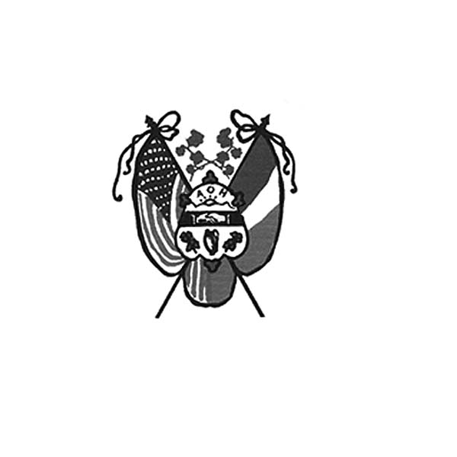
Ancient Order of Hibernians
of Hampden Hampshire Counties
PO Box 6535
Holyoke, MA 01041-6535
www.AOH-Holyoke.com

Next meeting – AOH – Monday, November 3, 7 p.m.
at The Irish Cultural Center
LAOH – Monday, November 3, 6 p.m. at The Wherehouse?

​ In ainm an Athar agus an Mhic agus an Spiorad Naoimh, Amen

Dear Brothers,

In partnership with the Polish National Credit Union, the AOH and LAOH are conducting a Food and Clothing Drive for Providence Ministries through December 1. Non-perishable food items, sleeping bags, blankets, and gently worn clothing can be dropped off at PNCU insurance service, 270 Westfield Road, Holyoke. Don’t forget to enter the raffle for a $100 gift card and a giant raffle basket. We value our partnership with PNCU to assist Providence Ministries each year and are grateful for the support from Hibernian Jim Kelly, CEO of PNCU.
I would like to say thank you to Dan Murphy and Aiden Moriarty for putting together a very successful membership drive and informational night at the Irish Cultural Center last month. We picked up some new members, and got the word out of who we are and what we do. I also would like to thank the members who attended and gave support. It was a great evening.
Just a reminder the November meeting will be held at the Irish Cultural Center, where we will be swearing in new members. Pizza will be served after the meeting.
We have a couple of events coming up, and I'm hoping for participation from the brothers .
Kate’s Kitchen needs food. Please drop of some non-perishable items at the Polish National Credit Union, 270 Westfield Road.
December 13 Wreath across America (more details to follow )
December 14 Kids Christmas party (more details to follow)
Joseph O’Connor President AOH Div. 1, Holyoke

Get your AOH March Calendars before we sell out. There are approximately 140 of our March 2026 raffle calendars left, and they will be available at our meetings. You can call or email Peter Hogan at 413-330-6635 / pjhogan71@gmail.com. He will also deliver them, if requested. Don't forget - they make great Christmas presents or stocking stuffers.

The Adult Christmas party will be Thursday, December 4,233 6-9 pm at Hamel’s in Holyoke.
For reservations, call Joe O’Connor at 413-627-7148 by December 1. Tickets for LAOH and AOH members are $10.00 each. Tickets are $20.00 for guests. The Christian Charity Award Winner, and this year’s LAOH and AOH Hibernians of the Year will be announced at the party.

Catholic Communications always publishes articles on our Maurice A. Donahue AOH Scholarship recipients. Check out this year’s story at the Diocesan website: iobserve .org. The article will also appear in the Catholic Mirror’s December Issue.

To Be Irish Is A Blessing, To Be a Hibernian an Honor
Attention AOH members!!! Our fiscal year for dues starts on November 1st of each year. Please get your $30.00 dues in for 2026. Contact Fin. Sec. Peter Hogan if you're not sure if you are up to date on dues. He can be reached by email at pjhogan71@gmail.com or by phone at 413-330-6635. Dues are $30.00 per year. Make checks payable to AOH & please mail to Peter Hogan, 22 County Road, Holyoke MA 01040-9606.

The AOH and LAOH will be preparing PB&J sandwiches for Kate’s Kitchen on Sundays, November 2 and December 14. Contact Rose Pratt if you want to help at 413-532-1677. Margaret’s Pantry Needs: meals in a can like Chef Boyardee, instant potatoes, peanut butter, stuffing, elbow macaroni, ziti, and soups. Please drop off items at Polish National Credit Union, 270 Westfield Road, Holyoke, or bring items to the November meeting at the Irish Cultural Center or to the Christmas party.

LAOH News
Dear Sisters,
At the beginning of October, a handful of ladies volunteered at the Mater Dolorosa Spaghetti Supper. They requested a few helping hands to serve, and our ladies stepped right up to the plate — literally, the spaghetti plate! Thank you to Rosie Pratt, Kit Collamore, Peggy Reynolds, and myself for volunteering and representing our Division with such wonderful spirit.
On October 11, we proudly entered Saint Brigid’s Brick in the annual Holyoke Brick Race. A very special thank you goes out to Rosie Pratt for coordinating and making sure our brick arrived at the starting line on time. I would also like to thank all the spectators who came out to cheer our brick on. She may not have taken the title, but she certainly came pretty darn close!
A special thank you also goes to Patti Clayton and Peggy Reynolds for assisting Joe and myself in helping the Holyoke Catholic Class of 1968 set up the balloon arch for their 75th birthday celebration at the Elks on October 12.
Thank you as well to all the ladies who participated in the Magic for Maddie event at the Holyoke Elks—it was wonderful to see such a strong LAOH presence there. On that same day, Jill Tellier served as our liaison to Jericho, ensuring that our delivery of candies and trinkets arrived in time for their annual Trunk or Treat—thank you, Jill!
Looking ahead to November, we will be making peanut butter and jelly meals on November 1 at Rosie Pratt’s house. All are welcome to attend. Our next Division meeting will be held on November 3 at 6 PM at The Wherehouse? 3rd floor. Big Thank you to Sam and Scott for taking care of us every month.
Please also remember that St. Jerome’s Parish will be holding its annual Craft Fair on November 9 from 9 am to 3 pm at the Our Lady of Guadalupe Gymnasium. Several of our members are parishioners there, so please consider stopping by to support!
Looking ahead to December, please mark your calendars:
• December 9 – LAOH State Quarterly Meeting in Lynn, MA at 11:00 AM.
• December 13 – The Division will volunteer at the Agawam Cemetery for Wreaths Across America, and we’ll also hold our Peanut Butter & Jelly Project that same day (time to be announced).
• December 14 – Children’s Christmas Party – Santa and his elves would love a few extra hands! Please see Kit Collamore after our next meeting or give her a call (413) 364-7484 if you’d like to help.
I am also very excited to share that Holyoke will soon be the site of one of the upcoming State Quarterly Meetings—dates and details to follow!
Thank you all for your continued participation and spirit—it truly makes a difference in everything we do. If you would like to assist or hear more about any of these wonderful opportunities, please don’t hesitate to reach out to me at 413-627-7149.
Yours in Friendship, Unity, and Christian Charity,
Mary K O’Connor
LAOH Div 2 Holyoke President

In ainm an Athar agus an Mhic agus an Spiorad Naoimh, Amen

Our LAOH State President, and Holyoke Division Historian, Noranne Duquette has asked for assistance with the National LAOH Irish History Contest. Awarded will be cash prizes of $250.00-$1000.00 for grades 6-8, and $500.00-$1500.00 for grades 9-12. This 2025 topic is "The Irish and the American Revolution- How the Irish affected the outcome of the American Revolution." For more information, contact Noranne Duquette at 413-210-3830 or masspresidentlaoh@gmail.com. She will be at the November meeting, with more details.

Upcoming Events

PB&J for Kate’s Kitchen - Sundays, November 2 and December 14. Contact Rose Pratt if you want to help at 413-532-1677.
Children’s Christmas Party – Sunday, December 14. Contact Kit Collamore (413) 364-7484 if you’d like to help.
Adult Christmas Party - Christmas party: the Hibernian adult Christmas party will be Thursday, December 4, 6-9 at Hamel’s in Holyoke. For reservations by December 1, call Joe O’Connor at 413-627-7148. Tickets for LAOH and AOH members are $10.00 and $20.00 for their guests. The Christian Charity Award Winner, and the LAOH and AOH Hibernians for 2026 will be announced at the party.
Irish Night – Saturday, February 28 at the Log Cabin. Details to follow at the November meeting.
Communion Breakfast – Sunday, March 14. Details to follow
Saint Patrick’s Parade - Sunday, March 21.

Irish Cultural Center News

The Trinity Pub
The Trinity Pub is open Wednesday–Saturday with the pub open from 4 – 10 p.m. with dinner served from 5 – 9 p.m. The bar is now open on Sundays from noon to 6 p.m. (drinks only). For reservations and gift certificates call 413-342-4358.

Remember the AOH in Your Will

Please consider the Order when writing or rewriting your will, and add a paragraph with the lines of “I leave to the Ancient Order of Hibernians in America (X percent of my estate or a specific dollar amount) for its charitable works.”

Bridget Ann Allen’s name was picked for the 50/50 raffle. Bridget was not in attendance at the meeting. You have to be present to win. The 50/50 is now at $30

The Healy’s Irish Radio program is on the air every Saturday from 9 a.m – 11 a.m. on WARE Radio, 97.7 FM and 1250 AM. It is also streamed online at classichits977.com and available anytime at healysirishprogram.com.
In continued memory of Doc Dean and our commitment to Kate’s Kitchen. Providence Ministries is in need of canned goods. Please bring a can or two to the meeting on Monday night.

To Be Irish Is A Blessing, To Be a Hibernian an Honor

