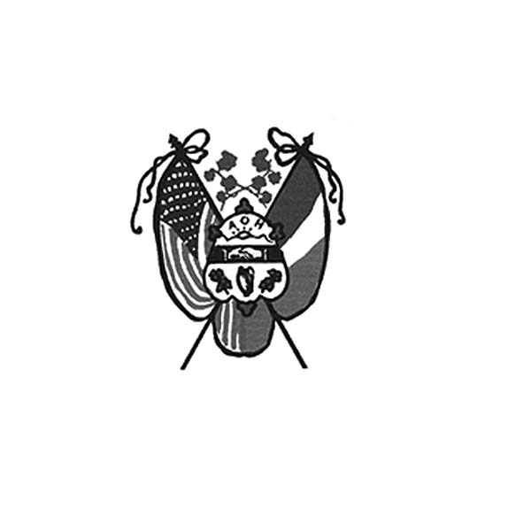 **Ancient Order of Hibernians**

**of Hampden Hampshire Counties**

PO Box 6535

Holyoke, MA 01041-6535

[www.AOH-Holyoke.com](http://www.aoh-holyoke.com/)

Next meeting – **AOH** – Monday, October 6, **7 p.m.**

at The Wherehouse?

**LAOH** – Monday, October 6, 6 p**.m**. at The Wherehouse?

**Dear Brothers,**

**In partnership with the Polish National Credit Union, the AOH and LAOH are conducting a Food and Clothing Drive for Providence Ministries through December 1.** Non-perishable food items, sleeping bags, blankets and gently worn clothing can be dropped off at PNCU insurance service, 270 Westfield Road. Don’t forget to enter the raffle for a $100 gift card and a giant raffle basket. We value our partnership with PNCU to assist Providence Ministries each year and are grateful for the support from Hibernian Jim Kelly, CEO of PNCU.

**The Big E Parade went off without a hitch. Once again, Peter Hogan did a great job working with Big E officials and Holyoke City Councilor and AOH member David Bartley for putting this together**. JD Watson and his vintage Hot Rod was definitely a show stopper while the rest of the Hibernians were rocking the trolley. A good time was had by all and thanks to all who participated.

**All AOH members!!! Save the date. Our chairperson Daniel Murphy and co-chair Aiden Moriarty will be heading up a membership drive this month. Please help out and join us for this important event. The drive will be held on Thursday, October 9, 5 to 8 pm at the Irish Cultural Center of Western New England, 429 Morgan Road, West Springfield.** Currently we have 94 members. We would like to see it increase to over 100 as we have done in the past,

Joseph O’Connor President AOH Div. 1

**Congratulations to AOH member Mike Sugrue on being to the new president and CEO of the Polish National Credit Union replacing retiring President and AOH member Jim Kelly.**

**Welcome to our newest members of the AOH, Jim Lawrence, Mike Kirkpatrick, Jim Buckley,**

**Jeff Fournier, Kevin Jourdain and Marc Rogers**

**2025 Saint Patrick’s Calendar Raffle tickets have been printed and are available at the October meeting.** Four hundred and fifty tickets have been printed. Last year we sold out so get your tickets early. Call Peter Hogan at 413-330-6636 or he can be reached at [pjhogan71@gmail.com](mailto:pjhogan71@gmail.com). They make great stocking stuffers.

**In ainm an Athar agus an Mhic agus an Spiorad Naoimh, Amen**

**LAOH NEWS**

**Dear Sisters-**

**I hope this newsletter finds you all well. First, a heartfelt thank you to the Peanut Butter & Jelly Committee for gathering at Kim Gaughan’s home on September 13.** The next Peanut Butter & Jelly session will take place on Saturday, October 4 at Rosie Pratt’s house, with another date set for November 1.

**Wasn’t it wonderful to see such a great turnout at Holyoke Day at the Big E!**

**A special thank you to those who supported the Ancient Order of Hibernians by attending the celebrity bartending night at the John Boyle O’Reilly Club,** where all proceeds went to Lorraine’s Soup Kitchen.

**And what a perfect day we had for the golf tournament—everything from the weather to the sponsors, players, and crowd came together beautifully. Special thanks to our Golf Tournament Chair, Nora Driscoll McMahon, for her outstanding leadership** in making the day such a success. A highlight of the event was when our 2025 Lady of the Year, Cheryl Dupont, sank a 25-foot putt, adding even more excitement to an already joyful day. It truly shows what we can accomplish when we all work together toward one goal.

**Also, we couldn’t forget that the Clothing & Food Drive sponsored by the Polish National Credit Union.**  It continues until December 1, 2025.

**I’d also like to welcome Rosie Pratt back from her vacation. Rosie** returns to the 413 on September 28 and will be swearing in our new members at the October meeting. I hope to see everyone there on October 6 at 6 at the Wherehouse ? .

**In addition, some of our ladies will be doing celebrity bartending at the Irish Cultural Center** Thursday, October 2 from 5:30–9:00 PM. This special evening will be in support of Each Moment We’re Alive, and if you have a little free time, your presence would mean so much to the bartenders and the cause.

**Thank you all for your kindness, dedication, and spirit.** I look forward to all the wonderful events we have planned for October, November, and December!

Mary K O’Connor

LAOH Div. 2 Holyoke President

**Our new LAOH State President, and Holyoke Division Historian, Noranne Duquette has asked for assistance with the National LAOH Irish History Contest.** Awarded will be cash prizes of $250.00-$1000.00 for grades 6-8, and $500.00-$1500.00 for grades 9-12. This 2025 topic is "The Irish and the American Revolution- How the Irish affected the outcome of the American Revolution." For more information, contact Noranne Duquette at 413-210-3830 or [masspresidentlaoh@gmail.com](mailto:masspresidentlaoh@gmail.com). She will be at the October meeting, with more details.

**Upcoming Events**

**Kate’s Kitchen -** October 5, November 2 and December 14

**AOH Membership Drive –** Thursday, October 9 at the Irish Cultural Center, 5 – 8 pm

LAOH at Jericho - On October 18 the LAOH will be volunteering at the Trunk or Treat Halloween celebration at Jericho, where our ladies will be volunteering (more details at the October meeting)

**Irish Cultural Center News**

**The Trinity Pub**

The **Trinity Pub** is open Wednesday–Saturday with the pub open from 4 – 10 p.m. with dinner served from 5 – 9 p.m. The bar is now open on Sundays from noon to 6 p.m. (drinks only). For reservations and gift certificates call 413-342-4358.

*To Be Irish Is A Blessing, To Be a Hibernian an Honor*

**Remember the AOH in Your Will**

**Please consider the Order when writing or rewriting your will,** and add a paragraph with the lines of “I leave to the Ancient Order of Hibernians in America (X percent of my estate or a specific dollar amount) for its charitable works.”

Bridget Ann Allen’s name was picked for the 50/50 raffle. Bridget was not in attendance at the meeting. You have to be present to win. The 50/50 is now at $300

**The Healy’s Irish Radio program is on the air every Saturday from 9 a.m – 11 a.m. on WARE Radio, 97.7 FM and 1250 AM. It is also streamed online at classichits977.com and available anytime at healysirishprogram.com.**

**In continued memory of Doc Dean and our commitment to Kate’s Kitchen.**  Providence Ministries is in need of canned goods. Please bring a can or two to the meeting on Monday night.

**50/50 raffle –** Bridget Allen’s name was chosen and he was not at the meeting.

**In ainm an Athar agus an Mhic agus an Spiorad Naoimh, Amen**