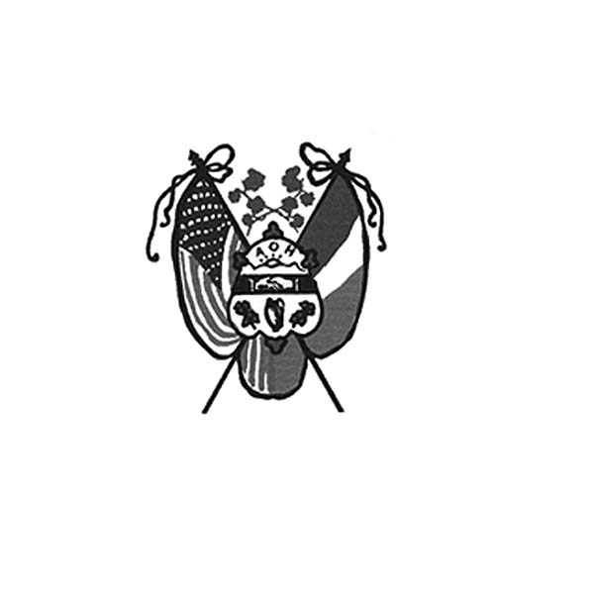 **Ancient Order of Hibernians**

**of Hampden Hampshire Counties**

PO Box 6535

Holyoke, MA 01041-6535

[www.AOH-Holyoke.com](http://www.aoh-holyoke.com/)

Next meeting – **AOH** – Monday, September 8, **7 p.m.**

at The Wherehouse?

**LAOH** – Monday, September 8, 6 p**.m**. at The Wherehouse?

​**In ainm an Athar agus an Mhic agus an Spiorad Naoimh, Amen**

**Dear Brothers,**

**I hope everyone enjoyed their summer vacation.**  As we start another year, we are “Being Part of the Solution” with our charity donations, our vast community service, and rewarding students with scholarships while promoting Irish culture and heritage . September starts our 3 month food and clothing drive in partnership with the Polish National Credit Union. This year we received a national AOH award for our efforts to stop hunger. With your help, we can help feed the hungry and clothe the needy .

The LAOH will be holding its annual golf tournament. The ladies are looking for golfers and volunteers. They are also asking for a $5 scratch ticket from each of our members. The ladies are indispensible helping with raffles at Irish Night and the Hennessey Hoe-down.

Thank you to Rick Connell from the Watertown AOH for organizing the summer trip to the Red Sox and for entertaining the Holyoke Hiberians with a post game BBQ at his house. It was a great time and he is planning this for next year .

Below is a list of upcoming events:

Sept.8- AOH meeting at The Wherehouse? 7pm

Sept 20 - LAOH Golf tournament (please see website)

Oct 6- Membership meeting at The Wherehouse? 7pm

Oct 9 - Information and membership drive at the Irish Cultural Center 5pm to 8pm

Joseph O’Connor President AOH Div. 1

**We are grateful to all who supported the summer picnic.** The Healys were a welcome addition.. Over 150 people attended. CEO Tony Basile from Hamel’s was most cooperative and generous . The food was delicious. Paul Mengel and the scholarship committee presented $1,000 each to Emma Kelly, Maela Allen, Peter Pluta and Riley Allen. Thanks to the LAOH on donating 45 baskets for raffle. Thanks to Joe and Mary O’ Connor for their leadership. Thanks to Paula Paoli and Peter Hogan for providing the games for the children.

**Welcome to the 4 newest members of the AOH, Jim Lawrence, Mike Kirkpatrick, Jim Buckley and Jeff Fournier.** **Running through December 1, the AOH and the Polish National Credit Union is again sponsoring a Food and Clothing Drive.** Items can be dropped off at the PCNU branch, 270 Westfield Road, Holyoke. Make a donation and you will be entered to win a raffle basket. **Hibernians, Jim Kelly and Shane Hall will be celebrity bartenders at a benefit for Lorraine’s Soup Kitchen** on Thursday, September 18, 6 – 8 pm at the John Boyle O’Reilly Club, 33 Progress Ave., Springfield.

*To Be Irish Is A Blessing, To Be a Hibernian an Honor*

From **Peter Hogan, Financial Secretary**: A total of 11 members owe dues. Multiple Notices have been sent out. Please remit your dues payment of $30.00 per year, made out to the AOH, and mail to Peter Hogan, 22 County Road, Holyoke, MA 01040-9606.

Get ready for our **March 2026 Calendar Raffle**. Please help out by selling as many raffle calendars as possible. This year, we have a total of 450 calendars to sell, and they will be available beginning at our Sept. 8 meeting.

**LAOH News**

**Dear Sisters,**

**I hope this newsletter finds you all happy and healthy after our summer break.**

The months of June and July were filled with activity! Our Golf Committee is working hard reaching out to sponsors in preparation for our upcoming tournament on September 20 at the Holyoke Country Club. Other members generously donated, gathered, and dropped off prizes for the event.

A special thank you goes to the ladies who spent June, July, and August preparing peanut butter and sandwich meals for our local Kate’s Kitchen. Your dedication and commitment to our community are unwavering.

This summer also brought opportunities for fellowship and fun. Several of our Hibernian women and men enjoyed the Saw Doctors concert, a Red Sox game, as well as the annual picnic at Hamel’s where four scholarships were awarded. At the picnic, we also celebrated a very special moment as one of our newest Ladies’ members, Heather Duggan, officially became a member of the LAOH.

There will be much to discuss at our September 8 meeting, and I look forward to seeing you all there. I kindly ask each woman, if possible, to bring a $5 or $10 scratch ticket to the meeting. The men of the AOH will also be asked to help. Together, these donations will create a significant Lottery Tree, one of the major prizes at the golf tournament. Your small contribution will have a big impact! Please hand ticket or cash to Peggy Reynolds at the next meeting as she is assembling the tree for the ladies.

In addition, we will be collecting personal hygiene items and clothing for our veterans at the Soldiers’ Home. These donations will be gathered at the Ladies’ Golf Tournament. If you have any questions, please reach out to Kathy Krisak from our division.at [krisakkk@comcast.net](mailto:krisakkk@comcast.net). The Holyoke Veterans Home wish list is also on the website.

Please also keep in mind the many events coming up in the next few weeks:

• **September 11** - 6 pm at Mary O’Connor; s house 55 Mayer Dr, Holyoke for assembly night for all baskets for the golf tournament

• **September 13** – Peanut Butter & Jelly at Cheryl Dupont’s home, 17 Lexington Ave. Holyoke, (all are welcome!) at 10 am

• **September 16** –Holyoke Day at the Big E – Hibernians have always been invited to take part in the parade .. (details to follow)

• **September 18, 6–8 pm** – Tribute to Chicopee Night at the John Boyle O’Reilly Club, with several of our AOH members as celebrity bartenders.

**September 20** – Golf Tournament at Holyoke Country Club

• **October 18** – Trunk or Treat at Jericho, where our ladies will be volunteering (more details at the September and October meetings)

Also, don’t forget that the Clothing & Food Drive sponsored by the Polish National Credit Union continues until **December 1, 2025.** As fall approaches, fresh ideas are always welcome as we continue working together to make a positive impact on our community.

With gratitude and sisterhood,

Mary K O’Connor- Div 2 Holyoke Pres.

**Our new LAOH State President, and Holyoke Division Historian, Noranne Duquette has asked for assistance with the National LAOH Irish History Contest.** Cash prizes of $250.00-$1000.00 for grades 6-8, and $500.00-$1500.00 for grades 9-12 will be awarded. The 2025 topic is "***The Irish and the American Revolution- How the Irish affected the outcome of the American Revolution***." For more information, contact Noranne Duquette at 413-210-3830 or [masspresidentlaoh@gmail.com](mailto:masspresidentlaoh@gmail.com). She will be at the September meeting, with more details.

**Upcoming Events**

**Kate’s Kitchen – Peanut Butter & Jelly September 13, October 5, November 2 and December 14**

**Holyoke Day at the Big E** – Tuesday, **September 16** (more details at the September meeting)

LA**OH Golf Tournament-** Saturday, **September 20** at the Holyoke Country Club. To register

contact Nora McMahon at [driscona@gmail.com](mailto:driscona@gmail.com).

**AOH Membership Drive –** Thursday, **October 9** at the Irish Cultural Center, 5 – 8 pm

**Irish Cultural Center News**

**The Trinity Pub**

The **Trinity Pub** is open Wednesday–Saturday with the pub open from 4 – 10 p.m. with dinner served from 5 – 9 p.m. The bar is now open on Sundays from noon to 6 p.m. (drinks only). For reservations and gift certificates call 413-342-4358.

**Please keep the family of Mary Ryan, Past LAOH National President, from Marlboro, MA, in your prayers.** Mary loved attending the Holyoke St.Patrick Parade.Shementored many Holyoke members through the years, and as a result, three Division. 2, Holyoke members have been honored to serve as LAOH MA State Presidents. Members from Holyoke recently paid their respects to Mary at her funeral services.

**Once again, congratulations to our newest MA State Board President from Holyoke,**

**Noranne Duquette!**

Remember **the AOH in Your Will - Please consider the Order when writing or rewriting your will,** and add a paragraph with the lines of “I leave to the Ancient Order of Hibernians in America (X percent of my estate or a specific dollar amount) for its charitable works.”

**The Healy’s Irish Radio program is on the air every Saturday from 9 a.m – 11 a.m. on WARE Radio, 97.7 FM and 1250 AM. It is also streamed online at classichits977.com and available anytime at healysirishprogram.com.**

**In continued memory of Doc Dean and our commitment to Kate’s Kitchen.**  Providence Ministries is in need of canned goods. Please bring a can or two to the meeting on Monday night.

**50/50 raffle –** Patrick O’Connor’s name was chosen and he was not at the meeting.

**In ainm an Athar agus an Mhic agus an Spiorad Naoimh, Amen**