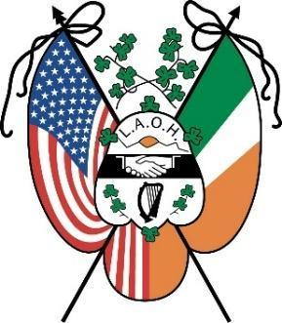
DATE
Dear Community Member,
The Ladies Ancient Order of Hibernians, Inc. (LAOH), Division 2 Holyoke chapter, is holding its annual Par 3 golf tournament on Saturday, September 20, 2025, at Holyoke Country Club. Proceeds from the event will benefit the LAOH in various initiatives, including the Maurice Donahue Scholarship Fund.
We are kindly asking for your sponsorship at the event. The sponsorship levels are enclosed.
The Ladies Ancient Order of Hibernians Inc. is a 501(c)10 sororal organization of American - Irish Catholic women. We have a 128-year history of service in the United States. As you well know, it is the community members like you that help support unity, friendship, faith, and traditions that the LAOH is proud to also uphold.
If you would like to play in the golf tournament or attend the lunch, please contact Nora McMahon at 413-218-2092 or driscona@gmail.com or register here. It is $60.00 for golf and lunch or $25.00 for lunch only.
We look forward to hearing from you about this wonderful opportunity and your support.

Sincerely,
LAOH Sponsorship Committee
The Ladies Ancient Order of Hibernians, Inc., Division 2 Holyoke chapter

Enclosure

