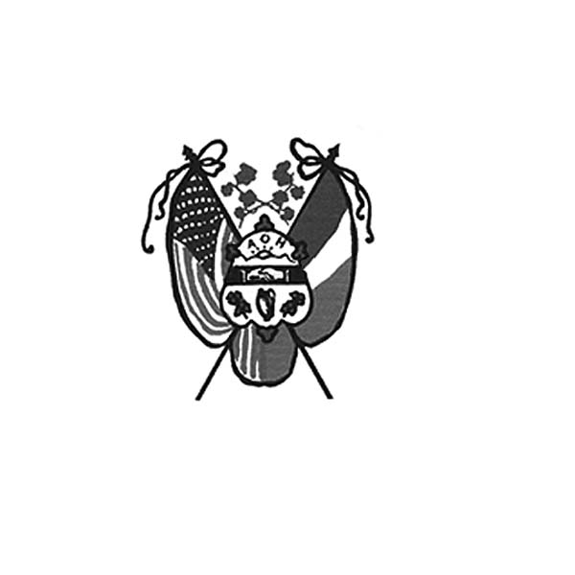
Ancient Order of Hibernians
of Hampden & Hampshire Counties
PO Box 6535
Holyoke, MA 01041-6535
www.AOH-Holyoke.com

Next meetings – AOH– Monday, January 5, 7 p.m.
LAOH – 6 pm
At The Wherehouse?

In ainm an Athar agus an Mhic agus an Spiorad Naoimh, Amen

Dear Brothers,

It was a beautiful and glorious holiday season. Merry Christmas and Happy New Year. Everything started with the adult Christmas party, where our 2026 awardees were announced: LAOH Woman of the Year, Kit Collamore, AOH Man of the Year, Jordan Lemieux, and the Christian Charity Award Recipient, Sr. Betsy Sullivan from the Sisters of Saint Joseph. It was a great night. Thank you to everyone who attended, the staff at Hamel’s Summit View for a wonderful meal, and the raffle committee, who did a great job. Also, special thanks to our newest member, Pic Dulude, for his donation.

The Holyoke AOH made a generous donation to Wreaths across America and many members participated in the laying of the wreaths at the Agawam Veterans Cemetery. This was a somber, yet gratifying day.

Thank you to the volunteers who worked at the Children’s Christmas party. Committee Chair Kit Collamore, Santa, (a.k.a. J.D. Watson) and the many elves (including Scott and Sam for their generosity) made it another memorable Christmas for the young boys and girls who attended. Thanks also to Santa’s official photographer, Peter Hogan.

I am looking forward to another happy and productive year and yes, St. Patrick’s Day is just around the corner.
Joseph O’Connor, President AOH Div.1, Holyoke

The Mass in Honor of St. Brigid, the Patron Saint of the LAOH, sponsored by the Holyoke LAOH, will be celebrated on Sunday, February 1, 8:00 a.m. at St. Jerome Church. AOH and LAOH members are encouraged to attend.
AOH March 2026 Raffle Calendars - Get them while they last. They are only $10.00 each. There is a daily prize of $50.00, with a grand prize of $500.00 on Saint Patrick’s Day, March 17. Contact Peter Hogan at 413-330-6635, if you need them dropped off to you. Calendars will be brought to the next two division meetings, if they are not sold out. Remember that if your name is drawn, it goes back in, so you have multiple chances to win.

Congratulations to Patty Clayton (Basket) and Julia Sullivan SSJ ($100.00 gift certificate to PICS) whose names were drawn as raffle prizes for donating to the food and clothing drive conducted by PNCU and Hibernians from September to December 1, for Margaret’s Pantry.

To Be Irish Is A Blessing, To Be a Hibernian, an Honor

Attention AOH members!!! Our fiscal year for dues starts on November 1st of each year. Please get your $30.00 dues in for 2026. Contact Financial Secretary Peter Hogan, if you're not sure if you are up to date on dues. He can be reached by email at pjhogan71@gmail.com or by phone at 413-330-6635. Dues are $30.00 per year. Please make your check payable to AOH, and mail it to Peter Hogan, 22 County Road, Holyoke MA. 01040-9606. As of the end of 2025, we have a total membership of 98. We still have 35 members that owe for 2026.

Thank you to Rosalie Pratt for her leadership and support over the years with the team that makes sandwiches for Kate’s Kitchen.

Kate’s Kitchen Sandwich Schedule [tentative] is as follows: ``````````````` January 24, March 7, April 11, May 23, and June 27.

Shout outs to Jordan Lemieux and John Gaughan for delivering clothing and food to Margaret’s Pantry that was collected at the PCNU, Polish National Credit Union this December. We are very grateful for their partnership with the AOH and LAOH. As Hibernians we are generous not only in spirit, but in our financial and material support to members of our community in need of assistance.

In addition, thank you to Hibernian Liam Smith who recently donated a significant amount of much needed food to Margaret’s Pantry. Thanks to everyone for your generous donations.

Non-perishable food items can be brought to meetings-meals in can like Chef Boyardee, instant potatoes, peanut butter, stuffing, elbow macaroni, ziti, and soups. We have also been asked to bring empty egg cartons to the LAOH and AOH meetings. They will be used to distribute eggs to the needy at Margaret’s Pantry.

LAOH News
P.O. Box 52, Holyoke, MA 01041-0052
Dear Sisters,

As 2025 ends, I want you to know how grateful I am for your kindness, dedication, and unwavering support. It has truly been an honor to work alongside such incredible women.

December was especially busy for our division. We began the month with the announcement of the 2026 Woman of the Year, and I am proud to share that it is Kit Collamore. Kit truly deserves this honor, as she is involved up to her neck in Hibernian activities and always ready to serve. I am very much looking forward to 2026 and all the wonderful things the Hibernians will continue to accomplish together.

Throughout December, we once again assisted Mater Dolorosa with their spaghetti supper. Other sisters assembled beautiful, warm throws that were distributed at the sing-along at Monastery Heights in West Springfield. Peanut Butter & Jelly did not take a rest this month as we prepared 50% more sandwiches than we normally do, due to the challenges many are facing in our economy.

We didn’t stop there. We proudly participated in Wreaths Across America, which was a deeply moving experience for all who represented the Hibernians. And finally, there were many, many elves at the Children’s Christmas Party on the 14th. I believe we had a record number of children and a record number of elves.

In ainm an Athar agus an Mhic agus an Spiorad Naoimh, Amen

I am also looking forward to January 5, our first Hibernian meeting of the year, where we will be swearing in new members and reviewing new applicants. This gives me great excitement and hope, as our division continues to grow. Thank you all for everything you do for our division. I wish you and yours a very Merry Christmas.
Mary K O’Connor
President, LAOH Division 2, Holyoke

Upcoming Events

Kate’s Kitchen - Sandwich Schedule [tentative]- January 24, March 7, April 11, May 23 and June 27
Please contact Rose Pratt at 413-532-1677, if you want to help.

St. Brigid’s Mass – Sunday, February 1, 8:00 a.m. at St. Jerome Church. All are invited.

Irish Nite – Saturday, February 28 at the Log Cabin:
Tickets will be $50.00 per person, with Valet Parking available. Featuring Keohane and Kennealy Irish-American Band, Corned Beef & Cabbage Dinner with Ribs, at the Log Cabin in Holyoke. For tickets, call Joe O’Connor at 413-627-7148 or Fran Hennessey at 413-785-5687. This event was sold out in past years.
More details to follow at the January meeting.

Flag-Raising – Monday, March 2nd-10:00 A.M. Kick-off to Irish American Heritage Month at Holyoke City Hall.
Communion Breakfast – Sunday, March 15. Immediately after 8:00 a.m. Mass at St. Jerome Church.
More details to follow

Daley & Halligan Memorial Ceremony-Tuesday, March 17, Northampton- more details to follow.

Saint Patrick’s Parade - Sunday, March 22. Volunteers are needed to help with float preparations, and to march with the ever-growing Hibernian Contingent.

Irish Cultural Center News
The Trinity Pub
The Trinity Pub is open Wednesday–Saturday, with the pub open from 4 – 10 p.m.
Dinner is served from 5 – 9 p.m. The bar is now open on Sundays from noon to 6 p.m. (for drinks only).
For reservations and gift certificates, please call 413-342-4358.

Remember the AOH in Your Will
Please consider the Order when writing or rewriting your will, and add a paragraph with the lines of “I leave to the Ancient Order of Hibernians in America (X percent of my estate or a specific dollar amount) for its charitable works.”

The Healy’s Irish Radio program is on the air every Saturday from 9 a.m – 11 a.m. on WARE Radio, 97.7 FM and 1250 AM. It is also streamed online at classichits977.com and available anytime at healysirishprogram.com.

To Be Irish Is A Blessing, To Be a Hibernian, an Honor

