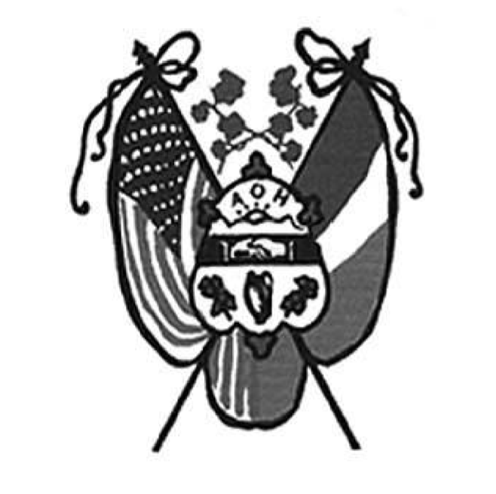
Ancient Order Hibernians of Hampden and Hampshire Counties
PO Box 6535
Holyoke, MA 01041-6535 www.AOH-Holyoke.com

Next meetings – AOH– Monday, June 1, 7 p.m.
LAOH – 6 pm
At The Wherehouse?

In ainm an Athar agus an Mhic agus an Spiorad Naoimh, Amen

Dear Brothers,
As we are winding down the year, we are gearing up for the Hennessy Hoedown on August 30. Please contact Ryan Allen at 413-531-3040 and/or Fran Hennessy at 413-8830-729 to volunteer, purchase tickets, or donate raffle prizes such as spirits or lottery tickets. Your support is greatly appreciated and helps make this event a success.

A big thank you goes out to Pic Delude for donating the pizzas at our May meeting. We also extend our sincere appreciation to Dinn Brothers, Samantha Methot and Scott Curran at The Wherehouse? for their continued generosity and support of our organization.

A number of members have still not paid their 2025 dues. Please remember that dues are payable in November for the upcoming year. Your dues help us continue the good work we do in our community and support the many charitable and cultural activities of our division.

Please keep the Gaughan and Donoghue families in your prayers. Thank you for your continued support and dedication.

We’ve hit 101! As promised by President O’Connor the club now has broken the century mark with 101members. At the May meeting, the club welcomed Conor Driscoll and Stephen Foley into our brotherhood.
Great thanks to the LAOH and the Ladies Cursillo group from Holy Cross Church in Springfield for making PB&J sandwiches for Kate’s Kitchen. Also, the next Kate’s Kitchen date to make sandwiches is June 27. The Ladies AOH will continue in July and August. If you want to participate, call Rose Pratt at 413-532-1677.
Continuing our community beautification, Hibernians are going to spruce up the Martin Dunn battery storage facility. This in addition to our manicured flower pot located at Cherry and Beech Sts. Check out both locations.

In memory of past Christian Charity Award recipient, Barbara Bernard, the club has donated $250 to the YMCA swim-a-thon to construct a family changing room.
The annual Summer Picnic unofficially named the “Hennessey Hoe Down” will be held on Sunday, August 30, 2026 at Hamel’s Pavilion in Holyoke from 1-5 pm rain or shine. The public is invited. The event will feature Healy's “Institute for Better Living”. A traditional cookout will consist of Hot Dogs, Hamburgers, toss salad, potato salad, dessert coffee (cash bar). For reservations call Ryan Allen or Fran Hennessey at 413-785-5687.

To Be Irish Is A Blessing, To Be a Hibernian an Honor

If you haven’t read the National Hibernian Digest, check out the obituary page. There is a nice write-up of Peter Hogan with photo.
Joe O’Connor/ President AOH Div. 1 Holyoke

LAOH News

Dear Sisters,
Once again, another month has rolled by, although this month carried a bit more sadness than previous ones, as we lost one of our own sisters, Mrs. Barbara Gaughan. I sincerely appreciate all of the members who took time out of their day to participate in the Ladies Hibernian Ritual for Barbara. It truly made an impact on her family, just as Barbara made such a lasting impact on all of us throughout the years. May she rest in peace.

Once again, you ladies rolled up your sleeves and showed up for the final spaghetti supper at Mater Dolorosa this past
May 6. Thank you for always stepping forward to help and support our parish community. A special thank you goes out to Peggy Reynolds, Cheryl Dupont, Kit Collamore, Rosie Pratt, and Deb Smith for taking part in the supper and helping make it another success. Please plan ahead, as the next spaghetti supper will be held on October 7. There will not be one in September, as the children will just be returning to school.
It was also very rewarding for the division to present Fr. Albert received a check for the school, in appreciation of his generosity and support to the ladies during their recent Irish Soda Bread Fundraiser, other members who were present were Peggy Reynolds, Rosie Pratt and Cheryl Dupont.

I would also like to thank all of the women who came to my house for the State Membership Planning Committee meeting. It was a wonderful success, and I truly believe that all of the little details will make a big impact and show the State that Holyoke is very much alive here in Western Massachusetts and that we take great pride in our Division.
Holyoke is honored to host the upcoming State Meeting on June 7, and I look forward to a very successful day.
I would like to thank Peggy Reynold for making 200 cards for our veterans for Memorial Day and delivering them along with member Jacki Readon to the Holyoke Veterans Home.

Thank you as well to all of the ladies who gathered at Rosie Pratt’s house on the 23rd for our peanut butter and jelly project. A special shout out once again to Rosie for always opening her home to us and helping create such a welcoming atmosphere for this important community outreach. Our volunteers were Peggy Reynolds, Joy Bartley, Pam Brough, Ann Kelly, Kit Collamore, Geri McCarthy, Jacki Readon, Marcia Gobeil, Michelle Liswell, Heather Lowe, Kathy Lawrence, Kathy Dunn, Krystenlee Pepin and myself. Our group continues to grow, and I know that we are truly making a difference in the community. Our new goal of preparing 150 peanut butter lunches each month is something we should all be very proud of.

I would also like to thank Kathy Dunn for serving as our liaison to the Veterans Lunch Program held every Thursday at Saint Paul’s Episcopal Church. We are grateful for the opportunity to be added to their volunteer rotation, and it appears that our Division will be serving on the fourth Thursday of each month. This is another wonderful opportunity for us to continue giving back to the community. Please reach out to Kathy Dunn if you are interested in volunteering for future lunches and details.
It was also wonderful to see members from Division 2 representing the State at the Watertown Memorial Day Parade. The Watertown Division continues, year after year, to go out of their way to make every attendee feel welcome and appreciated. State President Noranne Duquette joined past State Presidents Barbara Twohig and Paula Paoli, as they proudly carried the Holyoke’s Hibernian Banner in the parade.

I am very pleased to announce that during the month of May, we proudly swore in four new members: Margaret Lenihan, Terry Moreau, Krystenlee Pepin, and Tara Wolohan. I also look forward to our next meeting, where we will review two new applicants.

In ainm an Athar agus an Mhic agus an Spiorad Naoimh, Amen

Once again, our Division continues to grow, and with that growth comes even more opportunity for us to help our community and continue the important work of our organization.

The Ladies will soon be placing an order with Chris Ferriter for our LAOH apparel, please bring your completed form to the June meeting, remember check or venmo.

Also if anyone is interested in volunteering with Catholic Charities for their Mobile Pantry Food Bank, that was presented at our last meeting by Jessica Dupont please reach out to: s.coly@diospringfield.org( CORI check are required to volunteer)

Mary K. O’Connor President of Div 2 Holyoke

UPCOMING EVENTS
Kate’s Kitchen- Sandwich Schedule June 27, @10:00 am , contact Rosie Pratt if you want to help at 413-532-1677.
Next LAOH State Meeting-Sunday June 7, 2026 @ 12:00 – location: Pope John Paul II Social Center, 25 Maple St, Holyoke MA.
Hennessey Hoe -Down - Sunday, August 30,2026-The Hibernian Annual Traditional Summer Picnic will take place at Hamel’s Pavilion in Holyoke from 1-5 pm, rain or shine. The public is invited. The event will feature the Healys. A traditional cookout will consist of Hot Dogs, Hamburgers, chicken tenders for the kids, tossed salad, potato salad, dessert, and coffee (cash bar). For reservations call Fran Hennessey at 413-785-5687 or Ryan Allen at 413-531-3040. Tickets are $30 for adults and $15 for children 10-15. A children’s menu will be featured to include chicken nuggets, mac and cheese, lemonade and iced tea.
IRISH CULTURAL CENTER NEWS
The Trinity Pub
The Trinity Pub is open Wednesday–Saturday with the pub open from 4 – 10 p.m. with dinner served from 5
– 9 p.m. The bar is now open on Sundays from noon to 6 p.m. (drinks only). For reservations and gift certificates call 413-342-4358.
Remember the AOH in Your Will

Please consider the Order when writing or rewriting your will, and add a paragraph with the lines of “I leave to the Ancient Order of Hibernians in America (X percent of my estate or a specific dollar amount) for its charitable works.”

\ The Healy’s Irish Radio program is on the air every Saturday from 9 a.m – 11 a.m. on WARE Radio, 97.7 FM and 1250 AM. It is also streamed online at classichits977.com and available anytime at healysirishprogram.com.

In continued remembrance of Doc Dean, non-perishable food items can be brought to the February meeting. Items requested are meals in cans like Chef Boyardee, instant potatoes, peanut butter, stuffing, elbow macaroni, ziti, and soups. These will be delivered to the Providence Ministries.

To Be Irish Is A Blessing, To Be a Hibernian an Honor

