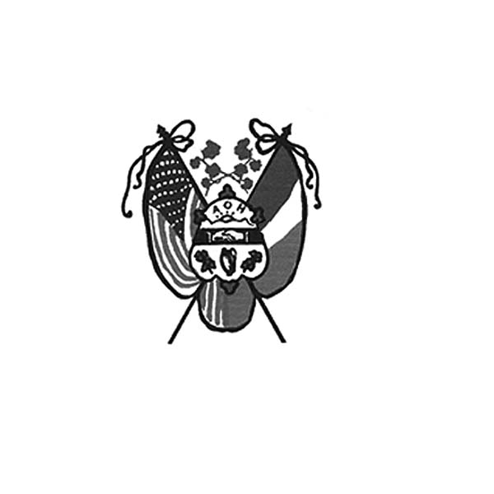
Ancient Order of Hibernians
of Hampden / Hampshire Counties
PO Box 6535
Holyoke, MA 01041-6535
www.AOH-Holyoke.com
Next meetings – AOH– Monday, May 4, 7 p.m at the Irish Cultural Center
LAOH will meet 6 pm. at The Wherehouse?.

In ainm an Athar agus an Mhic agus an Spiorad Naoimh, Amen

Dear brothers,

April was a little quieter than the Month of March

However ….. we did receive another $500.00 grant from the National AOH for our good work to provide food and clothing to the needy. This is no small accomplishment. We were 1of 20 divisions out of the 220 across the USA that received The Hibernian Hunger Project Grant. Thanks to everyone who participated, with special thanks to John Cadigan, Fran Hennessey, Jim Kelly, the Polish National Credit Union and our AOH brother, the late Peter Hogan, for all their work.
We also held a good meeting with Tony from the Summit View/ Hamel’s catering about the summer picnic. This year will include new menu items- chicken tenders and mac and cheese for children, along with free iced tea and lemonade for all to enjoy. Please get your tickets early.

President AOH Division 1
Joseph O’Connor

The May 4 AOH meeting will take place 7 pm at the Irish Cultural Center, Morgan Road, West Springfield. Members are encouraged to bring a friend and welcome them into our organization. Pizza will be served.
AOH Maurice A. Donahue Scholarships – Applications for the AOH Maurice A. Donahue Scholarships are available on the club’s website www-AOH-Holyoke.com. Applicants must be a son, daughter or grandchild of a member in good standing for 2 years. Applications must be postmarked no later than May 15.
Before we forget, congratulations to our Float Committee led by JD Watson on winning 2nd prize in the Religious Category at the Holyoke Saint Patrick’s Parade.
Great thanks to the LAOH and the Ladies Cursillo group from Holy Cross Church in Springfield for making PB&J sandwiches for Kate’s Kitchen. Also, thanks to the delivery people, Peggy Reynolds, Rose Pratt, Paul Mengel and Fran Hennessey for braving the storm. The next Kate’s Kitchen date to make sandwiches is May 24 and June 28. If you want to participate, call Rose Pratt at 413-532-1677.

To Be Irish Is A Blessing, To Be a Hibernian an Honor
Save the Date! The annual Summer Picnic unofficially named the “Hennessey Hoe Down” will be held on Sunday, August 30, 2026 at Hamel’s Pavilion in Holyoke from 1-5 pm rain or shine. The public is invited. The event will feature the Healy’s “Institute for Better Living”. A traditional cookout will consist of Hot Dogs, Hamburgers, tossed salad, potato salad, dessert, coffee and cash bar. For reservations & tickets, call Ryan Allen at 413-531-3040 or Fran Hennessey at 413-785-5687. The Maurice A. Donahue Memorial Scholarships will be presented. Thanks to the generosity of JD Watson, this year a children’s menu of chicken fingers, mac and cheese and lemonade have been added. There will also be face painting and balloon sculpting. The price is $30 for adults and children 16 and older, with younger children 10-15 years old $15.
Members are encouraged to bring lottery tickets for the lottery tree to be raffled at the summer picnic to the May meeting.
Beginning September 1 through December 1, the AOH annual food drive is again being partnered with the Hibernians and fellow Hibernian Michael Sugrue, CEO of the Polish National Credit Union. Drop off sites include Bresnahan Insurance on Whiting Farms Road, and Rush Insurance on Westfield Road.

Please keep in your prayers, Carol Smith, sister of Hibernian Liam Smith. Carol recently passed away in Ireland.

Also keep Patty Clayton in your prayers as she is recuperating after knee surgery and is anxious to get back on the tennis court and golf course.

LAOH News

Dear Sisters,

Here we are a full month later, and I would like to share a summary of all that the Ladies Ancient Order of Hibernians Division 2 accomplished during the month of April. We began the month by volunteering at the spaghetti supper at Mater Dolorosa, and the volunteers were: Kit Collamore, Mary Haley, Rosie Pratt, Cheryl Dupont, and myself. At a meeting on April 6, Rosie Pratt proudly inducted four new members: Mariellen Lenihan, Joy Bartley, Kerry Ross and Lisa Hamel. Each one of these individuals will bring so much talent and enthusiasm to our division. We also had the opportunity to review three additional candidates for upcoming membership which were overwhelmingly accepted by the division, and they are: Terry Moreau, Tara Wolohan and Krystenlee Pepin.
I would also like to give a big shout out to Mrs. Ryan for making such a beautiful, crocheted Afghan for another one of our fundraisers, please note- 100 percent profit. Congratulations to our winner, our very own Joanne Lusignan.
I am especially proud of the ladies who gathered on Saturday, April 11, to prepare 150 peanut butter meals, and they were: Kathy Lawrence, Kerry Ross, Joanne Beaudry, Eileen Leahy, Rosie Pratt, Angela Burke, Peggy Reynolds, Joy Bartley, Pam Brough, Jacki Readon, Kathy Brunelle, Cheryl Dupont, Marcia Gobeil, Kathy Sliwa, Michelle Liswell, Ann Kelly, Heather Lowe, Joanne Lusignan and AOH member Ryan Allen.
Your generosity and willingness to serve truly reflect the heart of our organization. I would also like to thank those who assembled over 2 dozen birthday cake kits. Those volunteers were Kathy Lawrence, Joanne Beaudry, Mary Haley, Rosie Pratt, Kerry Ross, Ann Kelly, Eileen Leahy, Angela Burke and AOH member Ryan Allen.
It was incredibly heartwarming to deliver them to Kate’s Kitchen and to meet the new director, Michael Nowak.

In ainm an Athar agus an Mhic agus an Spiorad Naoimh, Amen

It was wonderful to see such a strong turnout of Lady Hibernians at the 11th Annual spelling bee to support Homework House of Holyoke. Those in attendance were: Paige Leahy, Carolyn Leahy, Kim Gaughan, Cindy Murphy, and Marie Zurheide. A shout-out goes to our “Hornets” team—Eileen Leahy, Cheryl Dupont, and Kathy Dunn. While we may not have taken first place overall, you certainly took first place for best swag, ladies- and for your spirit and creativity. You made us all very proud.
There was an incredible turnout of Lady Hibernians to support our fellow sister Cindy Sheridan-Murphy at the Second Annual Pre-Kentucky Derby event –“‘Each Moment We’re Alive” ’hosted by Gary Rome of Holyoke. In attendance to show their support were: Cheryl Dupont, Kathy Dunn, Joanne Beaudry, Joan Grady, Heather Duggan, Angela Burke, Kim Gaughan, Callie Flanagan, Marie Zurheide and Kathy Lawrence. The event was beautiful, and the creative desserts prepared by our talented house chefs Cheryl Dupont, Kim Gaughan and Kathy Dunn were truly a highlight, and delicious.

Mary K. O’Connor
President of Div 2, Holyoke LAOH

UPCOMING EVENTS
AOH Maurice A. Donahue Scholarships – Applications for the AOH Maurice A. Donahue Scholarships are available on the club’s website www-AOH-Holyoke.com. Applicants must be a son, daughter or grandchild of a member in good standing for at least 2 years. Applications must be postmarked no later than May 15.
Kate’s Kitchen- Sandwich Schedule May 23, and June 27, @10:00 am. Contact Rosie Pratt if you want to help at 413-532-1677.
MD Spaghetti Supper-Volunteers to help serve on May 6, 2026, from 3:30 -7:15 p.m. For more details, call Mary K O’Connor @ 413-627-7149.
Next LAOH State Meeting-Sunday June 7, 2026 @12:00 Location: Pope John Paul II Social Center, 25 Maple St. Holyoke, MA.
Hennessey Hoe Down - August 30,2026-The Hibernian Annual Traditional Summer Picnic will take place at Hamel’s Pavilion in Holyoke from 1-5 p.m. - rain or shine. The public is invited. The event will feature the Healy’s “Institute for Better Living”. A traditional cookout will consist of Hot Dogs, Hamburgers, tossed salad, potato salad, dessert, coffee (cash bar). For reservations, call Fran Hennessey at 413-785-5687, or Ryan Allen at 413-531-3040. The Maurice A. Donahue Memorial Scholarships will be presented.

IRISH CULTURAL CENTER NEWS

The Trinity Pub
The Trinity Pub is open Wednesday–Saturday with the pub open from 4 – 10 p.m. with dinner served from 5 – 9 p.m. The bar is now open on Sundays from noon to 6 p.m. (drinks only). For reservations and gift certificates call 413-342-4358.

To Be Irish Is A Blessing, To Be a Hibernian an Honor

Remember the AOH in Your Will

Please consider the Order when writing or rewriting your will, and add a paragraph with the lines of “I leave to the Ancient Order of Hibernians in America (X percent of my estate or a specific dollar amount) for its charitable works.”

The Healy’s Irish Radio program is on the air every Saturday from 9 a.m – 11 a.m. on WARE Radio, 97.7 FM and 1250 AM. It is also streamed online at classichits977.com and available anytime at healysirishprogram.com.

In continued remembrance of Doc Dean, non-perishable food items can be brought to the May meeting. Items requested are meals in cans like Chef Boyardee, instant potatoes, peanut butter, stuffing, elbow macaroni, ziti and soups. These will be delivered to the Providence Ministries.

In ainm an Athar agus an Mhic agus an Spiorad Naoimh, Amen

