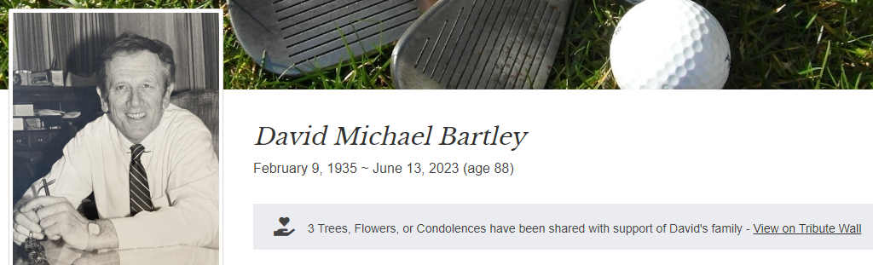
David M. Bartley passed away peacefully at home on June 13, 2023, surrounded by his loving family. A Holyoke native, Dave was the youngest of four brothers born to James and Mary Bartley. He was educated at Blessed Sacrament School and Sacred Heart High School, before graduating from Holyoke Junior College (now Holyoke Community College) in 1954, and the University of Massachusetts, Amherst in 1956. A skilled college athlete, the walk-on-turned-star player of the UMass basketball team was invited to try out for the Boston Celtics, and in 2005 was inducted into the UMass Basketball Hall of Fame. He also received both his master’s and doctorate degrees in education from his alma mater. He worked as a high school teacher and basketball coach before winning election to the Massachusetts House of Representatives in 1962, representing Holyoke for the next 13 years. He rose quickly in the House leadership, becoming Speaker of the House in 1969, a position he retained for four two-year terms. His many accomplishments in the State House included passage of Massachusetts Chapter 766 Special Education Law, which ensures equal access to public school. After serving as Speaker, he became the President of Holyoke Community College – a role he cherished – for the next 29 years. During his tenure, he transformed the school’s budget, programming, physical footprint, student size, representation, and significance in the collegiate system, establishing the first community college foundation in the state. In 2000, the college named the newly built 45,000-square-foot multi-purpose athletic facility, the Bartley Center for Athletics & Recreation, in his honor. Alongside his commitment to HCC, Dave continued to provide service to the state of Massachusetts when asked or when he believed he could help. He served as Governor Ed King’s Secretary of Administration and Finance from 1982-83 and ran for US Senate in 1984. He was a true public servant, balancing many local and statewide commitments. He served as a board member on several professional, civic, fraternal, and church organizations, including the Greater Holyoke Chamber of Commerce, the Holyoke YMCA, the Holyoke Children’s Museum, the Northfield Mt. Hermon School, the Ancient Order of Hibernians, the United Way, and the Federal Home Loan Bank of Boston. For his service, advocacy, and leadership, he received many awards, none more cherished than being selected the 1972 Grand Marshall of Holyoke’s St. Patrick’s Day Parade. Always fortified by his faith, he was a lifelong communicant of Blessed Sacrament Church, as well as a lector and Eucharistic minister. After retiring in 2004, the avid golfer split his time between Holyoke and Naples, Florida, where he took great pride in his single-digit handicap and in making an elusive hole-in-one. While his academic, athletic, professional, and civic career was impressive, his true love and greatest joy was his family. His wife Bette, a Turners Falls native, was the love of his life and the foundation upon which all his success was based. Together they built their family and shared 60 years of love and happiness. Dave savored family gatherings with the Bartley, Keough, and Anderson clans. He relished Christmas parties and summer backyard cookouts surrounded by his brothers, their families, cousins, and friends (even when he turned off the lights in summer and the heat in winter when he wanted everyone to go home). He is predeceased by his three brothers: James, John, and William, and their spouses, Patricia, Jeanne, and Delores. He is survived by his loving wife Elizabeth (Bette), his three children: David, of Holyoke; Susan, of Northampton; and Myles and his wife Beth, of Mount Vernon; his beloved grandchildren, Anna Elizabeth, Michael David, and Myles William of Mount Vernon, NY; and numerous nieces and nephews whom he loved. His Funeral Mass will be celebrated in Blessed Sacrament Church, 1945 Northampton Street, Holyoke, MA, on Tuesday, June 20, at 9:00 a.m., followed by burial in Saint Jerome Cemetery. Calling hours will be held at the Barry J. Farrell Funeral Home, 2049 Northampton Street, Holyoke, MA, on Monday, June 19 from 4:00 p.m. to 7:00 p.m. In lieu of flowers, donations in Dave’s memory may be made to Dr. David M. '54 and Bette Bartley Scholarship, Holyoke Community College Foundation, Holyoke Community College, 303 Homestead Ave., Holyoke, MA 01040, Blessed Sacrament School, or the charity of one's choice.

