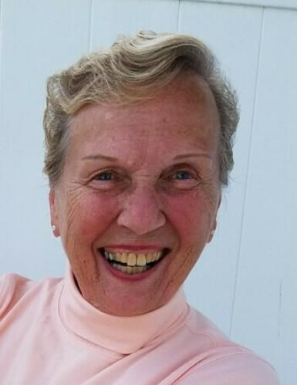
Barbara A. Gaughan
1938 - 2026
HOLYOKE
Barbara A. Gaughan, 88, of Holyoke, was called home after a long and happy life on Sunday, May 3, 2026. Born in Holyoke to the late Aldorf Boisjolie and Doris (Hamel) Boisjolie, Barbara graduated from the former Sacred Heart High School. Barbara was a lifetime member of the LAOH and enjoyed volunteering at Kate's Kitchen. She was nominated Woman of The Year in 2014. Music and dancing were Barbara's favorite pastimes. She enjoyed playing the organ, accordion, harmonica and teaching her grandchildren and great-grandchildren how to play the organ. Barbara's family was her everything, she could not spend enough time with her family. There was not a sporting event, recital, play or school event, that she would miss if her grandchildren were participating. Besides her parents, Barbara was pre-deceased by her husband, John, and siblings: Ernie, Edward, Millie, Francis, and Dorothy. She is survived by her three children: Joanne Beliveau (Scott) of West Springfield, Daniel and Barbara, and John (Kimberly) of Holyoke; five grandchildren: Amy (Jeff) Stanek, Chad Gaughan, Rachel, Lauren, and Katie Beliveau; five great-grandchildren: Nolan, Finn, Everly, Violet, and Fitz, a brother James of New York, and her lifelong best friend, Marion Schmidt of Chicopee. The funeral will be held on Wednesday, May 13, at 9:00 am from the Barry J. Farrell Funeral Home, 2049 Northampton St., followed by a Mass of Christian Burial in Blessed Sacrament Church at 10:00 am. Burial will be held at Saint Jerome Cemetery. Calling hours will be held in the funeral home on Tuesday, May 12, from 4:00 to 7:00 pm. Memorial contributions may be made to the Sisters of Saint Joseph of Springfield, 577 Carew Street, Springfield, MA 01104.

