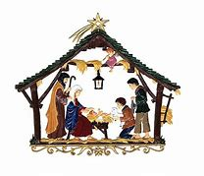

**Hibernian Christmas Party 2022**

**Mark it on your calendar and make your reservations!!**

The Adult Christmas Party is back for 2022.  This year’s event will be on Monday December 5th at **JP’s Restaurant, 200 Whiting Farms Road, Holyoke.**

A cocktail hour will be held from 6-7 p.m. followed by a buffet dinner at 7.

There is no cost LAOH members in good standing.

Guests and non-members are $20.00 per ticket.

**Contact Joe O’Connor at 413 627-7148 to reserve your seat(s).**

**The last day to make reservations is December 1st!!**

Please consider bringing a non-perishable can good for Kate’s Kitchen as well as a bottle of sprits for the Irish Night Raffle.

**Sponsored by the**

**Ancient Order of Hibernians**