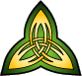
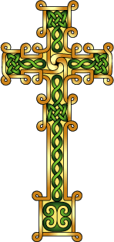
LAOH Capital District
Trinity Degree Team

Registration for Degrees

The exemplification of the Major Degrees of the Ladies Ancient Order of Hibernians
will take place on Sunday, September 29th, 2019 – 1:00 p.m. at the The Where-House located at 109 Lyman St., Holyoke, MA 01040. Registration begins at 12:15 p.m. and all candidates should plan to arrive by 12:30 p.m.

All LAOH members are welcome and encouraged to attend.
Please complete the form below and mail with your check made payable to:
LAOH Trinity Degree Team. Send the check and Degree registration information to:

Cathy Turck
PO Box 170
Altamont, NY 12009

The fee is $15.00 per person for Candidates and $10.00 per person for Observers.
Please note that an observer must have received her Degree.
The deadline for mail in registration is September 19th, 2019. For questions pertaining to the Degree, please contact the Degree Team Director, Cathy Turck, by email: cathyturck33@gmail.com
________________________Detach here and return portion below_____________________

I wish to attend the Major Degrees of the LAOH on Sunday September 29th, 2019

____ Candidate $15 _______ Certificate $5 (Optional)
____ Observer $ 10

Name______________________________Division Number/County__________________________________
Address__________________________________________________________________________________
City ________________________________________State____________ Zip________________
Phone Number _____________________________

