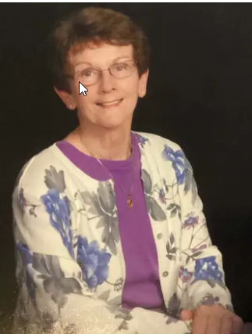
Mary Judith “Judy” Pratt entered her eternal rest on Monday, September 14, 2026, at Baystate Medical Center, surrounded by her children following complications from Alzheimer’s disease.
Born on July 30, 1944, in Holyoke, Judy was the daughter of Michael and Margaret (Cronin) Seward. She attended Holyoke Public Schools, graduated from Holyoke High School in 1962, and was a life-long Holyoke resident.
Judy’s life centered around family, faith, and her Irish heritage. Judy married Richard Pratt on June 22, 1963, at Holy Cross Church in Holyoke, and together they raised five children. Richard and Judy owned and operated Crabtree’s Service Station on Northampton Street in Holyoke for 42 years. She was an active communicant at Holy Family Parish where she taught religious education and served as a Eucharistic Minister. After the closing of the Parish, she continued her service for decades as a Eucharistic Minister at Our Lady of the Cross Church and counted the offertory collections every Tuesday.
Proud of her Irish heritage, Judy was a member of the Ladies Ancient Order of Hibernians Division 2, Holyoke. She marched for many years in the Hibernian Contingent of the Holyoke St. Patrick’s Parade. In 2013, she was honored as “LAOH Woman” of the Year an award recognizing someone who lives the organization’s motto of “Friendship, Unity, and True Christian Charity” and works for the betterment of the community. She was also a member of the Irish Cultural Center in West Springfield. Her travels to Ireland with her daughter, Rosalie, and with friends were among her most cherished experiences.
Above all, Judy treasured her family. She was a devoted daughter, sister, aunt, wife, mom, and Gramma. Her seven grandchildren were a constant source of joy and pride.
Judy leaves her children Kevin (Nicole), Rosalie, David Sr. (Karla), Brian (Jenn), and Timothy; and her beloved grandchildren, Kate, Mackenzie, David Jr., Michael, Julia, Casey, and Stella, as well as Casey’s mother, Sheila Moreau. She is also survived by her sister, Jane Fournier (John), sisters-in-law Kathy Seward and Sue Dupre; as well as her brother-in-law, Norman St. Aubin; and many nieces, nephews, friends, and the Hibernians.
Besides her parents, Judy was predeceased her husband Richard Pratt, her brother John Seward; her sisters, Barbara Pienkowski (Stanley), Peggy Parenteau (John) and Patty Brill (Dick); as well as her sister-in-law, Christine St. Aubin, and brother-in-law, Roland F. Pratt Jr.
Judy’s funeral will be held Wednesday, October 7, 2026, at 9:00am from the Barry J. Farrell Funeral Home, 2049 Northampton Street, Holyoke followed by a Mass of Christian Burial at 10:00 at Our Lady of the Cross Parish Church, Holy Cross Avenue. Burial will follow at St. Jerome Cemetery. Calling hours will be held on Tuesday, October 6, 2026, from 4:00 to 7:00 p.m. at Barry J. Farrell Funeral Home.
In lieu of flowers, donations in Judy’s memory may be made to the Alzheimer’s Association’s 2026 Walk to End Alzheimer's- Pioneer Valley- Holyoke, MA being held on October 25 on HHC’s campus. Please donate to: Team “LAOHdiv2”: https://bit.ly/LAOHdiv2.

