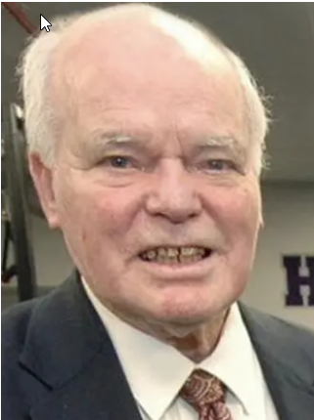
William "Ronnie" Collamore Obituary
William R. Collamore, age 92, of Holyoke, passed away on Saturday, September 19, 2026. He was born in Holyoke, a son of the late Leonard P. and Catherine (Farrell) Collamore and was educated in the Holyoke Schools. Ronnie was a Firefighter for the City of Holyoke. He was also a well-known local politician, representing Ward 6 on the Holyoke School Committee and was the longest serving elected official in Massachusetts history to date. A lifelong resident of Holyoke, he served in the United States Army from 1957 to 1959, and proud member of the American Legion. He was a communicant of Our Lady of the Cross Parish. Ronnie was a founding member of the Volleyball Hall of Fame, past President and 2-time recipient of the Mintonette Medallion of Merit. He also served as a Basketball Hall of Fame transportation volunteer escorting many HOF inductees including Red Auerbach, Larry Bird, Magic Johnson, Bobby Knight, and John Cheney just to name a few, an opportunity he was incredibly proud of. Ronnie also served as member of the Board of Directors of the Holyoke Boys & Girls Club and Golden Gloves Committee. He was also a member of IAABO, NASO, and ASA.
Ronnie is survived by three children: Venetta L. Hungerford and husband Michael of Holyoke, Deanna “Dee” O’Neill of Holyoke, and Kenneth Collamore and wife Christine of Bennington VT; thirteen grandchildren, seventeen great grandchildren, and a great great-grandchild. Besides his parents, Ronnie was predeceased by a son, Donald Collamore, three brothers: Leonard J., John A. and James F. Collamore, three sisters: Gail C. Flanagan, Nancy E. Stuart and Catherine A. McPhee, as well as his forty-year companion, Margaret “Peg” LaRiviere.
The funeral will be held on Tuesday September 29 at 10:00am from the Barry J. Farrell Funeral Home, 2049 Northampton Street, followed by Mass at 11:00am in Our Lady of the Cross Parish Church, Holy Cross Avenue. Burial will follow at the Massachusetts Veterans Memorial Cemetery, 1390 Main Street, Agawam at 1:00pm. Calling hours will be held on Monday September 28 from 4 to 7 pm. In lieu of flowers, memorial contributions may be made to the Holyoke Boys and Girls Club, Nick Cosmos Way, Holyoke MA 01040.

