SOCK, HAT & MITTEN DRIVE

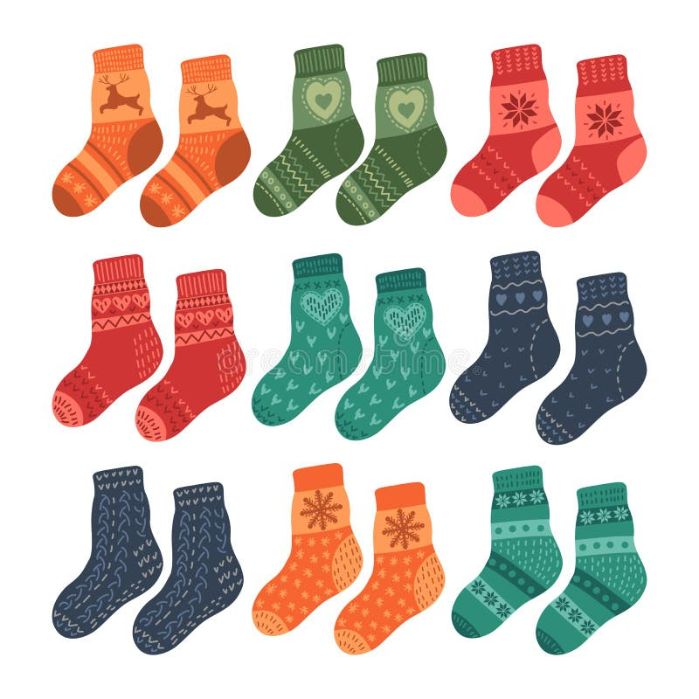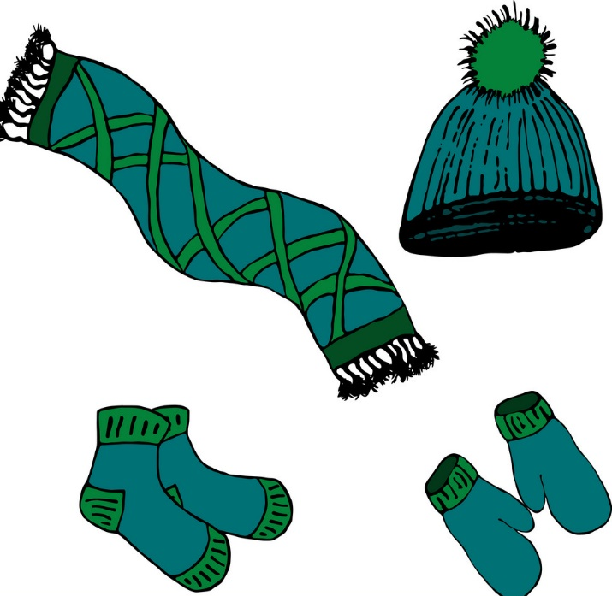
SPONSORED BY THE LADIES ANCIENT ORDER of HIBERNIANS
And PROVIDENCE MINISTRIES

